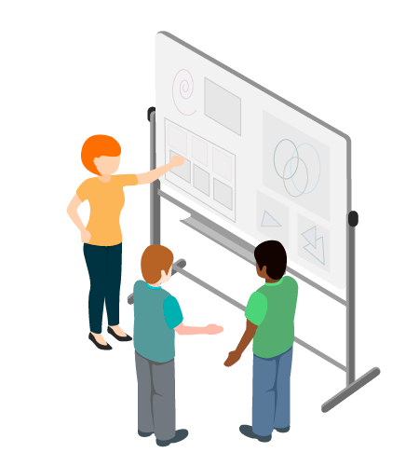

NCI Website Project

13 December 2018

Jason Smith: x017702485  
Muhammad Abu Bakar: x17112044  
Umer Iqbal: x17111854

Lamyae Naimi: x18114245  
Mark O’Kelly: x17742461

Estimation

Estimation is a technique used to predict the cost and effort required to take a course of action. The main reason for the use of estimation is to get an idea of the projected costs along with the time and effort involved with the undertaking of a project. It would not be practical or responsible to start a project without this information.

Estimation involves breaking the project down into smaller segments to get a better understanding of what cost and requirements will be involved at each stage. This can be done by a work breakdown structure. There are several different methods which can be used to arrive at an estimate with some being more effective than others depending on the project. The method that we will use is called PERT which involves a sample of three values (optimistic, pessimistic and most likely) and a formula used to calculate the weighted average. (IIBA 2015).

Benchmarking and Market research

The reason for undertaking benchmark studies is so that the practices in a project or business can be compared to the best practices being carried out in the industry. The result should then indicate if the business is being run efficiently or if changes should be made in certain areas. Market research is used is to obtain data from customers or end users and other stakeholders in the project to ensure that their needs are catered for.

Market research involves obtaining data from stakeholders which can be done by conducting a survey or by holding interviews and speaking to the relevant stakeholders. Benchmarking involves visiting the websites of other colleges and universities to note what the best practices or features are. Then we can use the data to decide if it is feasible to incorporate them into the project. (Cadle, Paul and Turner, 2015)

Data Mining

From Data, this technique helps to improve final decision by finding and using beneficial patterns. It is an analytical process that examine a huge amount of different data from different point of view and finalize, summarize that data in such a way that useful relationship and patterns will discover. The reason why I chose this technique for NCI website is because I found it most important and initial step toward this project. I am going to use it in such way. First, I will communicate to all different category of NCI webpage user like Students, Teachers, IT and Fee department etc and find out what are their issues? And what change they want. Secondly, I will try to view all these issues and wants in different aspects. Then I will link more than one problem. So single solution will attempt to solve more than one problem. Data mining is a kind of Mathematical model. Mathematical model and equations help me to determine right decision. The best thing about this technique is, it is predictive. It will help me to determine which changes will be more valuable in NCI project for long time future as well as solve the issues of current users and will meet today’s and future standard. (IIBA, 2015)

Business Rules Analysis

Is used to identify, express and validate rules that shape day to day business behaviours. Business policies and rules guide every day functions of the business and its processes, and shape already use business decisions. It is one of those techniques that use every day, every time. And every time when it uses, it uses for some solid purpose which have a big impact on certain task. Even this technique is using to validate old rules, with stakeholders every single time when they are going to use for some new task. This technique is very important as well as very useful for NCI project. Every project has fixed rules and policies for every situation. For NCI webpage development developers and all other members will face almost every day new problem. But sometimes these fixed rules and policies will not helpful then Business Rules Analysis will use to refine and organise that fixed rules and policies to solve this new problem. Good thing is, Clear defining and managing business rules will allow whole organisation to make valuable changes to rules and policies without alternating whole process or system. This technique will save us from big loss and issues like wastage of time and money, staff problems etc. And everyone will know he has some impotence and value in this project. (IIBA, 2015)

**Prototyping**

A method that we use in the early stages of our product or model to test which will give us result of our design known as Prototyping, this term that we use in the prototyping of the contexts including electronic and software programming etc. There are many reasons to use the prototyping, here are the some Further, if we will create a prototype it will help the project team to not only estimate but it will also check the product before working to the final manufacture.

As we know that, prototyping has become very important for all the companies, they always need to remember to make several prototypes before making the product. Before the production of our product or the model if we do the prototype, then we can find out that is there anything that needs to be improved or removed. Prototyping is the thing that will help the companies to keep the lowest cost of the product. The purpose of the prototyping is to show people the possible design of the of your project or product.

**There are few steps that involved in the prototyping:**

To find out what our user needs for the project or the product, and we can get these requirements from the interviews etc.

We need to develop a prototype by using any tool or high language and the report that needed to our user.

We need to stop the prototyping process when we will find out that we are finished, and we got the result

Workshops

Workshops is a time of discussion or some practical work on anything in which a group of the people will share their knowledge and experience with everyone. A workshop can be carried on the different things on our planning design scoping etc. These day’s people are using workshops to find out the new ideas about their product. We can use this time to talk on a topic or research on our design or something else.

**There are many things involved in the workshops:**

* A group of our colleagues get together and work on different topics and share their knowledge with each other's.
* Plan and work on that and get the result of your product.
* Collaborative learning in which two or more student study or work together asking the people with their ideas, information.
* We can use a facilitator in workshops, which will help the group to understand ______________________
* **Explanations**
* As we know that, most of the users of NCI Websites are students between 17-21 percentage and over 20%-year users are Master students or the professors. First, our group did the Market research and asked the questions from our stakeholders like do you NCI web and why don’t you like it. What features do you like most in the in the NCI websites, what features do you like least, do you need the direct access to One drive drop box etc. And the main issue does you need the home page on the home page of the NCI websites. How do you feel about the online top up in student card?
* So basically, we need to create the NCI websites most easy to use. For example, in our home page will we show all those things that we use on the daily bases. Many problems new students faced to searching the results, time tables. Keeping all of these in minds I created a prototype on a blank sheet of paper using Microsoft word. Everyone was happy with the logo of NCI on the websites, so I keep that on the same place top left-hand side. But, every new person like students have difficulties to find out the Moodle as I mentioned above. Then, I decided to make Moodle sign in link on home page where every new student can find it clearly. Then I put it on top right-hand side of the page right front to the logo of NCI, and under that I also make a link for staff portal to sign in. If we looked at the data mining and Market research, our stake holder said that we don’t need two bars on the home page. That’s why I created only one bars on home page of the NCI websites. But I think we can use two bars on the home page in second bar we can make some of that information that is currently on the websites like campus and library information, but anyway our focus is on stakeholders’ information. I created first most five buttons in bar of our home page. First one is home, if you are on the other page you just need to press the home button to come back on the main page. Then a lot of comments was we can’t find the courses details and fee’s information easily, that’s why I created a button next to home button which will show the information’s about all the courses and the fee’s info just with one click through your mouse. Later, you will see all the details of students like my details login, pay fee’s, exams, results and time table. After that, you will find, about button in this it is clear to see all the contents of the of the college and the contacts details of all the departments. In data mining, I see that it’s very hard to apply for admission, so I put it on the last, so you can easily apply, or you can contact the admission office all of these changes are made through our stakeholder demands, why they asked us to put this here because whenever you will apply for the admission it’s very hard to find out the courses and if you find and then most of the people couldn’t be able to find the fees information. This is the main reason that we put our all that main information that we need in the main front bar, and if we want, we can put the rest of the information that we deleted in the second navigation bar.
* Then, on next row you can find all the info about the news and event because this very important for the every company to keep updating their news and events and people will find this very easily and feel good, and right beside to this button you can see My apps because we need all our drop box, one drive, mails online word, draw.io, excel etc. We just need to click on the that then sign in and get all our apps easy to find and fastest. Now, if you see in our old website that our search bar is always looks like 90s movies, I mean oldest and specially you are not able to find this on the mobile phone and that’s why I tried to update search bar and put this on the right under our navigation bar which is latest and easy to see. Next row will show the picture of college on home page which will be in the jQuery’s form, because now all the pictures will change automatically in different styles which will make the beauty of sites more than previous ones or if you want you can keep it like the same, and same problems was with the content because stakeholders say’s that it’s very hard to see the content of the site on the mobile and now our contents in the bigger size which we can also see that on mobile easily. Our stakeholder’s say’s that how can we miss our memories we need keep our videos on the front of the websites and we added videos on next div, where college can keep their memory alive on these two div forever or whenever they want can change it. But as we know that, social media has become very famous in these centuries but many of the stakeholder say’s that we need to keep our social media’s apps on the somewhere, but I think it is important to keep in the same place wherever it is and you can also get some of the college information from there. So, we keep it on the left-hand side on the last of page because whenever we want can go through Instagram, Facebook, twitter etc. College can also keep their popular pages for the students or the staff just on the bottom of the page they can keep this private or public for everyone.
* So, all this information that we made is in our first version of the prototype version one related to our stakeholder information’s.
* **Version 1:**

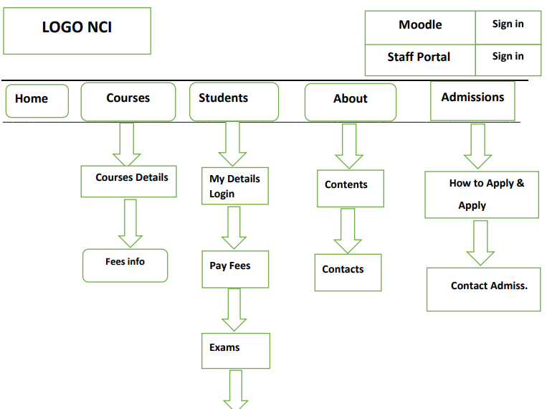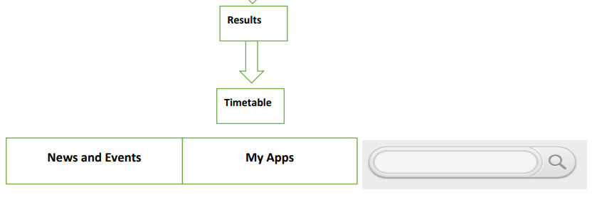

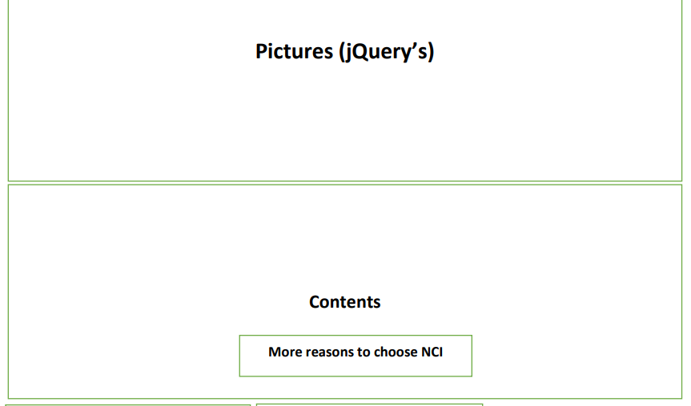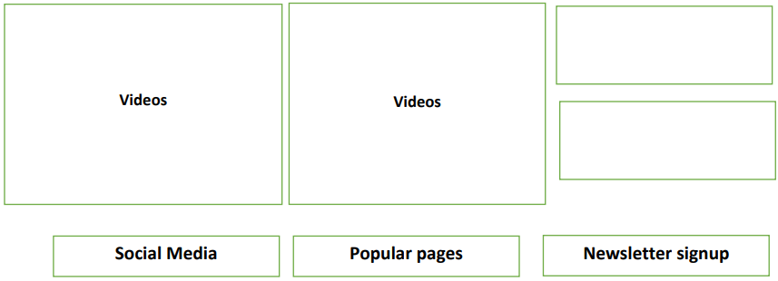

* Feedback from the stakeholders:
* Here is some feedback that we got from our stakeholders:
* Yes, this look like a big improvement and it looks nice to have Moodle link to top of the pages. I like this.
* Yes, I like this new design and I think it will work a lot better.
* As, a nearly every day users of the sites, this new prototype seems to me like a very big step in the right directions according to the organizations.
* It looks great and navigate, you must keep it that way.
* It is a big improvement but the navigate bar could be improve, e.g. I would use the time table more frequently than I pay fees so, this could be more projecting.
* Nice work but I would say that navigations bar on the top could be better.
* Huge improvement, well done guys. The only thing that I would like to make is to put the search box at the top of the page to make it easier to look just besides the logo and also drop down the navigations bar to make it easier.
* After getting all feedback from my stakeholders, it was cleared that we are moving to right directions most of them are satisfied that the websites must be look like this all the changes that we made was right putting the Moodle link on the top of the page, but I feel that in the meeting some of the stakeholders want to make the changes on our navigations bar because they said we put a lot of the extra things over there and one guy say could it will looks much better if you guys put the search bar just under the logo or beside the logo.
* Then, we got all the information from our stakeholders, we started to work on the next and last version of the prototype, because they asked us to make few changes and rest of the things are fine.
* So, in our second version of the prototype I put the search bar right under the logo and increase the length to look better than previous one. And also removed some information from the navigation bar. I removed the content button from the about and also little bit from courses and students.
* **Version:2**

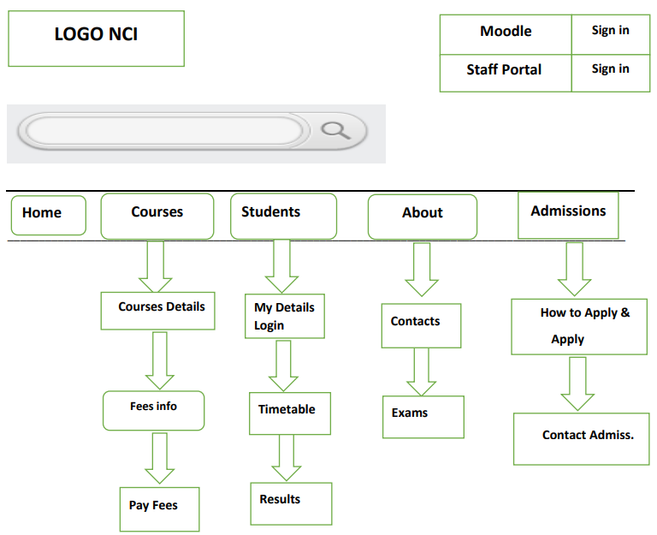

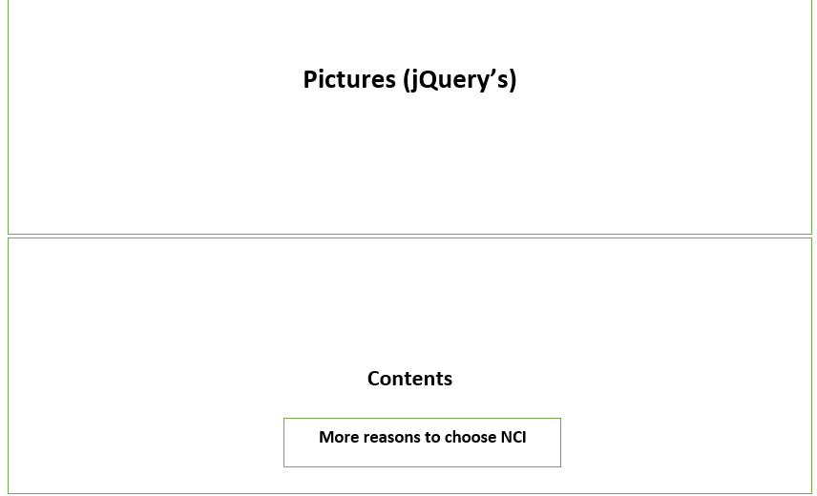

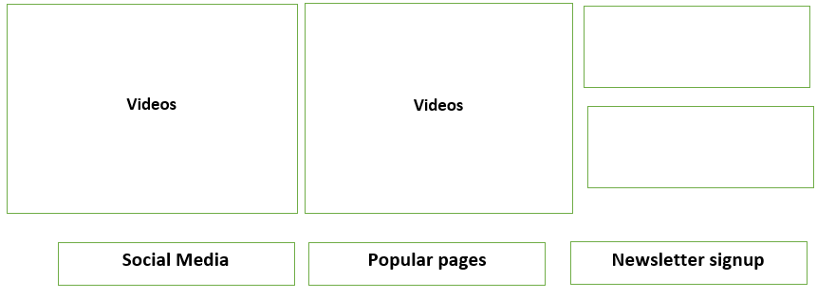

* Again, when we showed our final version of the prototype to the stakeholder there were satisfied with that and didn’t say anything to make the changes. They said this prototype might can change the NCI website.
* Feedback from the stakeholders:
* I like it, it’s good idea to have Moodle button and search at the top.
* I kind of like last one too, but this one is all good too.
* Love it, great jobs guys. A+++++
* Looks great so, when are you going to build it.
* Yep, that looks like nice improvement over the current website. Go for it
* Yes, it is good all of the things that I need is on the top. Good work.
* This definitely look like it would work. Excellent.
* The navigation is much cluttered now. Much better
* The new navigation bar looks really nice, that’s good work.

* **WorkShops:1**
* In workshops, we created an agenda arranged a meeting and set the locations in the college atrium. Everyone participated of the group and explain a bit of their techniques. First, Jayson Smith outline the process of estimation to the team. Explain all the method of the estimation to use. He explained many ways how to obtain the estimations for the project and discuss how to gain the data from the stakeholders. Later, Limaye explained root cause analysis. Discuss that how the problems will be solved and SWOT analysis techniques to the team. After that, Abu baker gave a brief explanation on the Data mining to all the members of the teams and talked all the requirements of the team and stakeholders. Then, Umer talked and outline on the prototyping to the teams analyse all the project NCI with groups and fix the goals, and same as everyone he talked on his second techniques and gave brief explanations to the teams. On last, Mark O’Kelly talked on data flow diagram to the team and create a data flow diagram for the understanding of it and talked on his second technique and shared his knowledge about the Decision Modelling to the team.
* So, on the last of the meeting we did the conclusion and made decisions what persons will do research’s/ investigation/ analysis and stick on that.
* **Workshops:2**
* In our second workshops, first we did some discussions on NCI websites and shared all our experience, Muhammed discussed all the information about Data mining related to the NCI websites that what he got the information from the stakeholder how to improve the NCI website through his techniques and showed us some practical example and screen shots of the previous websites and compare with the new one. And later, we opened some other colleges websites like UCD for better user experience, in DCU we find out faster loading experiencing, DIT we feel easier to use and in DBS we find the better layout then we compare them with the NCI website. Then later we opened our prototype and study briefly, where is our prototype what changes we made, and shared all the information of our stakeholder about our prototype. Everyone stakeholder was happy that we put the Moodle of student and staff portal on the top right-hand side, as we mentioned earlier that it was hard to find Moodle login. Then, our stakeholder mentioned that, the navigation bar that we put on the top there is a lot of the information, I mean five button they said we can put some of this information in second navigation bar on the top or under this navigation bar that we missed in our first prototype. We got most of the positive feedback, I mean we put almost all things on the home page that is necessary to keep on the front pages and, they liked our news and events and much more the My Apps that they find out better than all other things.
* At the end of our workshops, we plan to fill all those things that our stakeholder asked to do so e.g. navigation bar, social media, search bar etc. We also made a rough sketch over there to finalize how we need to make these changes and stick on that.
* **Workshops: 3**
* In our third Workshops, I arranged a meeting in NCI Atrium everyone came on time to for meeting. Today, we our meeting was on the NCI current business rules, what are they, can we improve that and why we need to improve these things.
* First of all, we choose to discuss about the fee office:
* Every student needs to pay his fees before the first semester exam, we were satisfied that otherwise without the fee’s payment no students are allowing to be sit in the exams.
* Is it ok for the internationals students to pay their first-year fee in one instalment, some was agreeing but some wasn’t because they think that most of the student can’t afford so It will be in three instalment?
* Is it ok that NCI must accept card no more cash? yes, everyone was satisfied that it must pay through the bank card because International student fees are 10000 euro, so nobody can take this big amount through cash.
* Student need to pay 25 euro for new student card, but we decided that it is too much NCI need to reduce his amount.
* Then, we choose to discuss on attendance:
* Is it ok, if the student attendance goes less than 50% and then he is not allowing to sit in the exams (Everyone was satisfied that this rule is ok he didn’t follow the class regularly and missed many then he must repeat that module because he doesn’t know what to do exactly)?
* Is every student needs to be on time, yes, we can’t say that everyone can’t be, some people came from too far they might be stuck in the traffic or they have their personal issues, but college still give them 15 minutes extra if they tap their card 15 min late then college will count this 100% attendance of the class? Everybody was happy with this rule.
* Then, we choose to discuss exams rules:
* Is every student need to clear his fees before the exams, yes, he must complete otherwise he won’t be allowing to sit on the exams?
* Is that important to stop the student to leave the room first and last 30 minutes yes, that’s important everyone was satisfied on that.
* Is NCI need to update Moodle for the exam, yes because it is important without that everyone will upload the file on the time and it will make the Moodle to crash easily. They can do this by making few more changes and can stop it from the crashing and save the heart.
* If a student forgets his student card at home on exams day or lost, he can’t sit in the exams. Does everyone agree on that? Most of the student as agree but few wasn’t and say college need to be used some other through his system to identify him/her. And the same thing is with college library, if he lost his card, he can’t enter in the library college need to arrange something to identify his identity and help him to enter into library.

SWOT:

1. **Description:**

it’s a business analysis technique that Evaluate the overall state of an organisation,

internally:

* Strength: identify positive factors that add value to the organisation and empower its competitive
* Weakness: identify negative factors exist in the organisation that can affect its position in the market.

and externally.:

* Opportunities: identify areas that can organisation take advantage of and add value
* Threats: consist of identifying external risks that have bad impact in the organization

1. **Why to use in the Project:**

I choose SWOT to help my team gather and organize information and have good vision of our project by creating lists of all the internal and external strengths, weaknesses, opportunities to help prepare, plan and avoid threats. This technique will provide valuable information to help develop a successful website that meet our stakeholder’s expectations and analyze factors that can be potentially harmful to be considered now and, in the future, and also will encourage my team to think critically and make better decision of how to redevelop the NCI website.

1. **What is involved:**

I will establish a meeting with proper stakeholders and my team and list all NCI website strengths, weaknesses, opportunities and threats, and focuses on major categories under each one of the four analysis areas that are important to the website’s success and what.

We will collect all documentation for relevant analysis that was done to the website in the past to collect correct data, to help us effectively start our analysis in the right direction.

The template below displays few initial estimated factors for NCI website: to be edited

|  |  |
| --- | --- |
| **S**trengths:   * value, quality? | **W**eaknesses:   * Timescales, deadlines and pressures |
| **O**pportunities:   * Market development | **T**hreats:   * Competition * Market demand * Financial and credit pressures |

***Chart Source BABOK (2015)***

Root Cause Analysis

1. **Description:**

problem-solving method used to trace an issue back to its origin, starts with Deep Systematic examination of a problem and then determine the appropriate solution to fix it depending on the technique results. it focusses on the problem origin and finding the true reason of failure that leaded to the creation of a problem, rather than its effects. This technique can be used for:

* **Reactive Analysis:** identify problem causes for Corrective Action:
* **Proactive Analysis:** identify potential problem areas for Preventive Action

Four Activities used in Root Cause Analysis:

* Problem Statement Definition: provide a clear description of the issue
* Data Collection: collect Information about:
* Nature of the effect: analyze the nature of the problem
* Magnitude of the effect: determine the level of the problem
* Location of the effect: identify where the problem occurs
* Timing of the effect: identify when the problem occurs
* Cause Identification: identify the root cause of a problem
* Action identification: describes the action need to be taken to minimize or prevent the problem

Two common tools used in this technique:

* **Fishbone diagram:** it’s a tool helps discover the root cause of a problem, it is used to identify multiple possible causes of a problem and relationship that exist between those causes.
* **5 whys:** Approach uses repeated Question asking process to explore the nature and root cause of a problem, which may come before or after the 5th why.

|  |  |  |  |  |  |  |
| --- | --- | --- | --- | --- | --- | --- |
| **Who?** | **What?** | **When?** | **Where?** | **Why?** | **How?** | **How many?** |
| Was involved | happened | Date and time problem were identified | Location  Of problem | Find explanation  For the problem | how did the problem happen and how it will be corrected? | Size and frequency of the problem |

1. **Why to use in the Project:**

I choose to use this technique to help my team build a shared understanding of the problem and be able to identify effective improvement actions that need to be done on NCI website to reach new requirements.

This technique will provide a clear guide for my team of areas that need special attention and Prevent the rework, this will help improve our team work performance.

1. **What is involved:**

**Step1:** Problem statement definition: break down issues into smaller individual issues, then organise and prioritise the issues.

**Step2:** Data Collection: collect as much Information required to detected best problem cause using fishbone diagram and 5 whys.

|  |  |
| --- | --- |
| Fishbone Diagram steps “to be edited later on the project” | 5 whys steps |
| 1. Capture the issue:   My Team will establish brainstorming meeting with proper stakeholders to capture issues, and make sure we define the problem correctly and that everyone agrees on the problem statement, then we will start drawing the fishbone diagram starting by  write the problem in the box on the right-hand side of the diagram and Draw spine of fishbone  and Drawing diagonal lines that represents categories of potential causes of problem and connect them to the "backbone" of the **fishbone chart**.   1. Drawing small lines to represent deeper causes | 1. prepare brainstorming meeting with team and proper stakeholders and get everyone to share ideas that will lead to the root cause of the problem. 2. Write the problem in the whiteboard 3. Ask the participants: why do you think we need to redevelop the NCI website? And Capture idea 1 4. Ask the participants: Why do you think Idea 1 occurred? And Capture idea 2. 5. Loop back in until the team convinced the actual root cause has been identified. |

**Step3** Cause Identification: our team will determine the best cause from all possible causes and consider it as root cause.

**Step4:** Action identification:

* Determine solution: we will identify all possible solutions, analyse and select the best for issue identified then **gather results and present it to appropriate stakeholders and management** to get feedback/ approval.
* Take action: we will provide a clear guide of the action that need to be executed in the project (Corrective and Preventive action).

As soon as the root cause is identified, recommendations that tackle the problem as quickly as possible should be drawn up.

**Data Flow Diagram:** (**Mark O’Kelly)**

These Diagrams shows us where data comes from, the activities that processes data, and if the results are stored or used by other activities or external factors. These reason why I chose this technique is because the diagram can be used as a discovery technique for data and processes. It allows us to define the scope of any system and many users find data flow diagrams easy to read. One important reason is that is helps in identifying any duplicated data or misapplied data element. These are some of the many reasons why we decided to use this technique as it with help us keep track of our project. One limitation for this technique is that it does not display a sequence of activities. (IIBA 253)

The diagrams portray the transformation of data and can be used to depict transaction-based systems and display the boundaries of any physical, logical, or manual systems. The diagram shows how data moves and transforms between processes and externals. An external or process output is the input of another and displays temporary or permanent repositories where data is stored in a system. These Diagrams can have many layers of abstraction with the highest-level diagram being a context diagram that displays the whole system. In diagrams at level 1 the input, output, transformed data, and data stores can show the processes related to the system. Further levels of the diagram can break down the processes from the first level. These level diagrams are useful in displaying the internal partitioning of the work. (IIBA 250)

There are four elements to this technique, the first one being Externals which are people, organisations, automated systems or devices capable of producing or receiving data. Externals are objects that are outside the system under analysis. Each external needs to have one data flow going to or from the data. The second element is Data Store which is a collection of data that can be read over repeatedly and where it’s stored for further use. In short, its data taking a rest and each data flow needs at the least one data flow going to or from it. The third element is Process and can be a manual or automated activity performed for a business reason. It also turns data into an output and naming standards for processes should have at the least one verb and noun. This element needs at least one data flow coming to and from it. The final element is Data Flow which is how data moves between an external, process and data store which is then displayed by data flows. This element holds the processes together and every data flow connects to or from a process. They also show the input and output of each process. (IIBA 251)

**Decision Modelling (Mark O’Kelly)**

Decision Modelling shows us that decisions in business are repeatedly made. The reasons I chose this technique is because this method allows us to share with stakeholder and facilitate an understanding between both stakeholder and programmer. Many perspectives can be shared and even combines and allows us to simplify complex decisions being made by removing business rule management from the process. It also helps with managing many rules in decision tables by grouping the rules by using decisions which help with reusability. However, one limitation to watch out for is that it may limit rules to any required decisions and limits the capture of rules that aren’t related to the decisions. (IIBA 268)

A straightforward model uses a single decision table or tree table to show how a set of business rules operate on a common set of data elements combined to decide. Whereas complex decision models break decisions down into single components where each piece can be described separately and show how these piece’s combine to make an overall decision. Information needed to decide, and any sub decisions can be de-composed. Comprehensive decision models are an overarching model where processes, performance measure, and organisations are linked to the model. Business rules that are involved in a decision can be definitional or behavioural and decision tables and trees are defined in how a specific model is made. Decision tables and tree tables define how specific decisions are made and Graphical decision models can be made at various levels. High level models can only show the business decisions as they appear in business processes, but a more detailed model could show as-is or to-be decision making in enough detail to act as a structure. (IIBA 265)

For elements in this technique there are many ways to approach decision modelling. Decision tables stand for the rule needed to make atomic decisions. Decision trees are common in some industries but are used nearly as much as the decision table with the latter being used more often. Complex decisions need the combining of many simpler decisions into a network, which is shown as using dependency or requirement notations. All in all, each approach involves only three important elements which are, knowledge, decision and information. (IIBA 265)

**Technique Plans**

|  |  |  |  |
| --- | --- | --- | --- |
| **Estimation (J.Smith)** | | | |
| **Event** | **Start Date** | **Finish Date** | **Team Member** |
| 1. Group meeting    1. Outline the process of estimation to the team.    2. Agree on which components of the project to be estimated.    3. Decide on which of the methods of estimation to choose.    4. Discuss best possible ways to obtain estimates for the project. | 23/10/2018 | 23/10/2018 | J.Smith  All Team Members |
| 1. Decide most optimistic estimates for the components agreed in step 1. | 24/10/2018 | 27/10/2018 | Muhammad |
| 1. Obtain variety of estimates from different sources. | 24/10/2018 | 27/10/2018 | Lamyae |
| 1. Decide on worst possible total estimate from available data. | 24/10/2018 | 27/10/2018 | Umer & Mark |
| 1. Use all available data to calculate final most accurate estimate. | 29/10/2018 | 30/10/2018 | J.Smith |
| 1. Group meeting   6.1 Discuss estimated costs and decide how to proceed. | 30/10/2018 | 30/10/2018 | All Team Members |

|  |  |  |  |
| --- | --- | --- | --- |
| **Benchmarking and Market Analysis (J.Smith)** | | | |
| **Event** | **Start Date** | **Finish Date** | **Team Member** |
| 1. Group meeting    1. Outline the process of Benchmarking and Market analysis to team.    2. Discuss methods to obtain data from stakeholders | 23/10/2018 | 23/10/2018 | J.Smith  All Team Members |
| 1. Determine areas to be studied    1. Examine NCI website and student portal    2. Make notes of areas to improve | 24/10/2018 | 30/10/2018 | Muhammad and Umer |
| 1. Visit websites from competing colleges.    1. Note best practices and stand out features. | 24/10/2018 | 30/10/2018 | J.Smith  and  Mark and Lamyae |
| 1. Group meeting    1. Compare findings from stage 3.    2. Determine what best practices from competitors can be improved or included in project. | 06/11/2018 | 06/11/2018 | All Team Members |
| 1. Group meeting    1. Outline the process of market analysis to team.    2. Identify stakeholders to acquire data from.    3. Discuss best methods to obtain data from stakeholders. | 06/11/2018 | 06/11/2018 | J. Smith  All Team Members |
| 1. Obtain data from stakeholders using methods decided in step 5.3 | 7/11/2018 | 9/11/2018 | J. Smith  and Lamyae |
| 1. Group meeting    1. Discuss all findings and examine data.    2. Decide on plan to proceed. | 11/11/2018 | 11/11/2018 | All Team Members |

|  |  |  |  |
| --- | --- | --- | --- |
| **Data Mining** |  |  |  |
| **Event** | **Start Date** | **Finish Date** | **Team Member** |
| * 1. Group meeting      1. Gather all requirements from team and Stake holders.      2. And need for NCI website. | 23/10/2018 | 23/10/2018 | All Team Members |
| * 1. Collect all data and information regarding to that requirements. | 29/10/2018 | 4/11/2018 | Muhammad Abubakar |
| * 1. Examine all this data and info from different perspective. | 29/10/2018 | 4/11/2018 | J. Smith |
| * 1. Deep understanding of all data. So, we can use it in our own ways. | 5/11/2018 | 10/11/2018 | Mark |
| * 1. Summarize it in such way that useful patterns and relationships are discovered. | 5/11/2018 | 10/11/2018 | Umer |
| * 1. Group meeting      1. Show all findings to team members and stakeholders.      2. Do necessary changes if required. | 11/11/2018 | 11/11/2018 | Muhammad  All Team Members |
| * 1. Apply all data and findings to the NCI project. | 13/11/2018 | 13/11/2018 | Lamyae & Muhammad Abubakar |

|  |  |  |  |
| --- | --- | --- | --- |
| **Business Rules Analysis** |  |  |  |
| **Event** | **Start Date** | **Finish Date** | **Team Member** |
| * 1. Group meeting      1. Make list of all rules and policies.      2. Ask to staff and stakeholders if they have any concern about rule or they want to put more rules. | 23/10/2018 | 23/10/2018 | All Team Members |
| * 1. Deep knowledge of all rules and policies for better understanding and implementation. | 26/10/2018 | 05/11/2018 | J.smith |
| * 1. Set conditions when each of it will implement. | 26/10/2018 | 05/11/2018 | Lamyae naimi |
| * 1. Flexibility in rules for everyday new problems | 05/11/2018 | 10/11/2018 | Lamyae naimi  & Umer |
| * 1. Organize that rules in such a way that shape day to day business behavior. | 05/11/2018 | 10/11/2018 | Mark |
| * 1. Group meeting      1. Show all changes to rules and policies.      2. Brief conditions for rules. | 11/11/2018 | 11/11/2018 | Muhammad  All Team Members |

|  |  |  |  |
| --- | --- | --- | --- |
| **Data Flow Diagrams** |  |  |  |
| Event | Start Date | Finish Date | Team Member |
| 1. Group Meeting    1. Outline the processes of Data flow diagrams to the group.    2. Create a data flow diagram with the team. | 23/10/2018 | 23/10/2018 | All Team Members |
| 1. Create template    1. Research over templates and examples of diagrams. | 25/10/2018 | 28/10/2018 | Umer |
| 1. Create Level 1 diagram    1. Create further levels for decomposing the diagrams | 25/10/2018 | 28/10/2018 | Muhammad |
| 1. Review template    1. Review final template    2. Discuss with group to any changes    3. Finish the template | 11/11/2018 | 11/11/2018 | All Team Members |
| 1. Finish Diagram | 13/11/2018 | 13/11/2018 | All team members |

|  |  |  |  |
| --- | --- | --- | --- |
| **Decision Modelling** |  |  |  |
| Event | Start Date | Finish Date | Team Member |
| 1. Group Meeting    1. Outline processes of decision modelling    2. Discuss Decision modelling with the team | 23/10/2018 | 23/10/2018 | All Team Members |
| 1. Create template    1. Research templates and example of decision modelling | 25/10/2018 | 05/11/2018 | Lamyae |
| 1. Diagram decision    1. Agree whether to use the decision tree diagram or decision table | 25/10/2018 | 05/11/2018 | J.smith |
| 1. Review template    1. Review final template    2. Discuss with group on any changes needed    3. Finish template | 11/11/2018 | 11/11/2018 | All Team Members |
| 1. Finish diagram |  |  | Umer |

|  |  |  |  |
| --- | --- | --- | --- |
| **Prototyping** |  |  |  |
| **Event** | **Start Date** | **Finish Date** | **Team Member** |
| 1: Prepare for first meeting.  1.1: Schedule meeting (location, time, and people)  1.2: Prepare material needed for meeting (white board, papers, pens) | 23/10/2018 | 23/10/2018 | All Team Members |
| 2: Conduct meeting:  2.1: Explain prototyping for my team  2.2: Analyze the project NCI with group  2.3: Determine project goals | 26/10/2018 | 5/11/2018 | All teams |
| 3. Create concept of the prototyping  3.1: Make idea on paper  3.2: Make virtual prototype  3.3: Make physical prototype | 6/11/2018 | 6/11/2018 | Someone |
| 4: Concern with Specialist | 11/11/2018 | 11/11/2018 | Someone |
| 4.Meeting with stakeholders: gather feedbacks from stakeholders  5: Apply feedback and make changes to meet stakeholders' requirements  5.1: Testing the previous prototype | 13/11/2018 | 15/11/2018 | Someone |
| 6: get stakeholder approval for the final prototype.  6.1: Transport the final prototype to be executed in the project | 16/11/2018 | 16/11/2018 | Someone |

|  |  |  |  |
| --- | --- | --- | --- |
| **Workshops** |  |  |  |
| **Event** | **Start Date** | **Finish Date** | **Team Member** |
| 1: Analyze the project (NCI with group) | 23/10/2018 | 23/10/2018 | All Team Members |
| 2: Plan a Workshops | 25/10/2018 | 5/11/2018 | Lamyae naimi |
| 3: Before  the Workshops (Arrange the meeting)  3.1: Define the goals  3.2: Arrange who will attend  3.3: Find out the right location  3.4: Make an agenda  3.4.1: Main points  3.4.2: Visual points  3.4.3: Discussion  3.4.4: Activities | 6/11/2018 | 15/11/2018 | Someone |
| 4: Make and follow the plan. | 16/11/2018 | 17/11/2018 | Someone |
|  |  |  |  |
|  |  |  |  |

|  |
| --- |
|  |

**Break down of Data Mining**

* Firstly, we need to sit with all our team member’s and stake holders and collect all the requires and their needs for the NCI project. And all these requirements are according to the NCI website users wants.
* Secondly, gather all data and information regarding to each requirement. For Example, visit different websites, meet with wed developers etc. to solve the issues.
* Then examine all those data and information, what we get from different sources. Examine it from different perspective.
* Deep understanding of all those data and information, so we can manipulate it and use it for our own issues to solve it.
* Summarize and manipulate it in such a way that useful patterns and relationships will discover. Means if we have better understanding of all issues, data and requirements. With every single action we can solve more than one problem. It saves our time, cost and allow us to do something more.
* Again, sit with all members and stake holders, show all the findings and solution to them briefly. Take their feedback and perform all the necessary changes if required.
* At the end apply it to the NCI website project for good and advance change.

**Break down of Business Rules Analysis**

* Make list of all rules and policies. Ask to staff and stakeholders if they have any concern with all these rules or they want to add some more rules that will help them in future for the project.
* Try to get deep and better knowledge of all these rules and policies for better understanding and implementation. Because before the project starts its compulsory to explain all rules and their punishments if they break any rule. It is good practice to make discipline and for success of project.
* Set and explain all the conditions when each of it will implement.
* Rules need to be flexible to deal with everyday new problem. Rules are for help not to create more problems. That’s why it need to be flexible.
* Organize that rule in such a way that shape day to day business behavior and prevent them from losses (big or small).
* Show all these changes to rules and policies to staff and stake holders. Explain them and ask them if they have any issue. If they have tried to solve it.

**Data Mining**

* 80% of NCI Web Page users range from 17-21 years (Students).

20% ranges after 21 years (Masters Students, Professors, other departments staff)

Firstly, we need to focus on Students requirements than any other users because they are the major users of web page and portal (Moddle, Citrix etc.).

* Except Computing students, IT Department and Computing Teachers, the rest users have Good or Above Average of computer/ technical ability. So, we need to make NCI web page easy to use or handle. Most problem is faced by Beginners and those who are searching Colleges to get admission. They found very difficult to find some information like Timetable, fee info, results, course details etc.
* Throughout a day NCI web page and portal are attracted by Students time to time. NCI also need to give student App like DIT. It saves their time instead to open web page and login every time to access their data. This app will give acess to every thing like Moddle, dropbox,outlook, citrix etc.

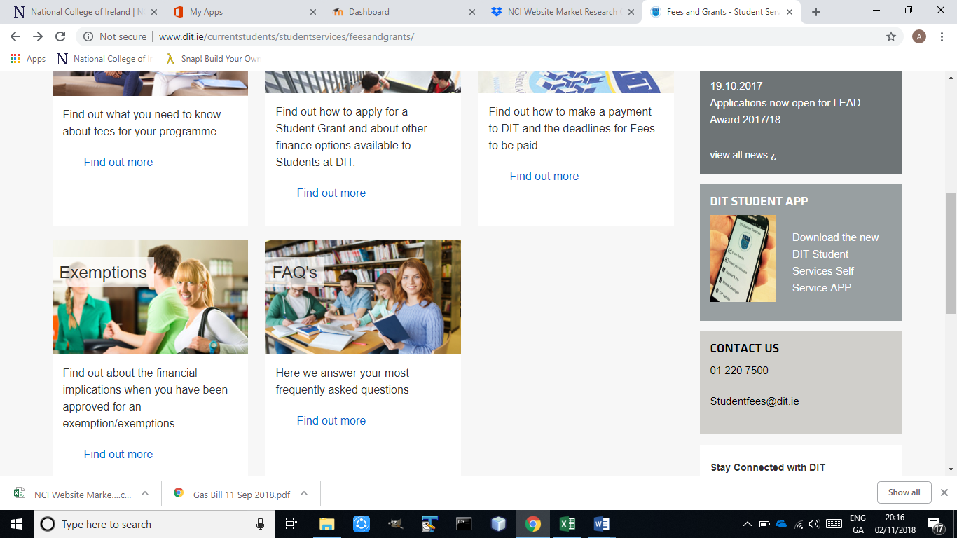

* Everyone is using NCI webpage more than once a day. So, we need to check its traffic capacity / hosting capacity to prevent it from being down when traffic size increases.
* Smartphone is most common and most famous device these days as compare to other electronic devices. Students and staff members like to access NCI site and portal through their phones. It’s easy, safe and fast instead of logging-in to someone else desktop or laptop. Need to create mobile version of NCI site and portal to show all its contents properly.
* Features like most by Students and Staff of NCI web page

1. Forums and latest updates:- it helps them to know what will going to be happen in future . so, they will start preparing for it if they want. It’s a very good thing to attract old and new students for different activities.

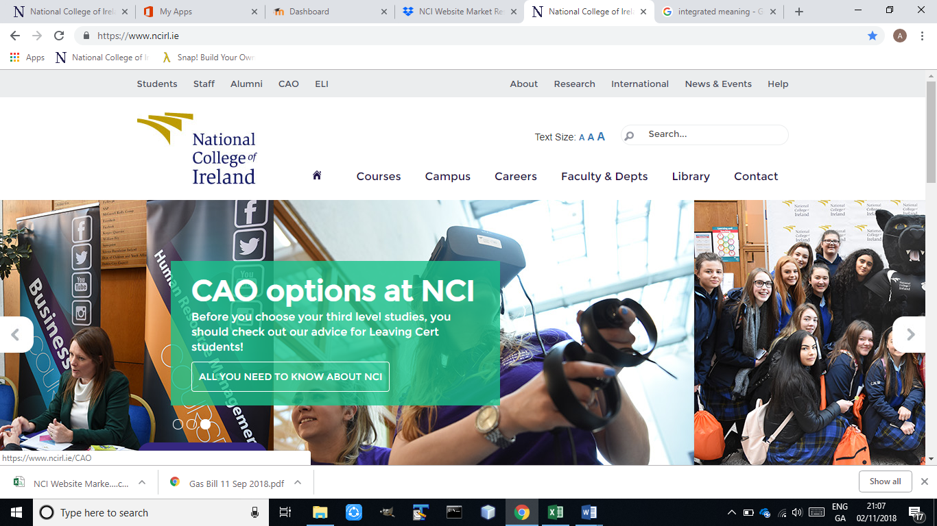

1. Social Media integration:- These days, as we all know the best,fast and most attractive way to communicate among students is through social media. It saves time, money and most quick to spread important informations.

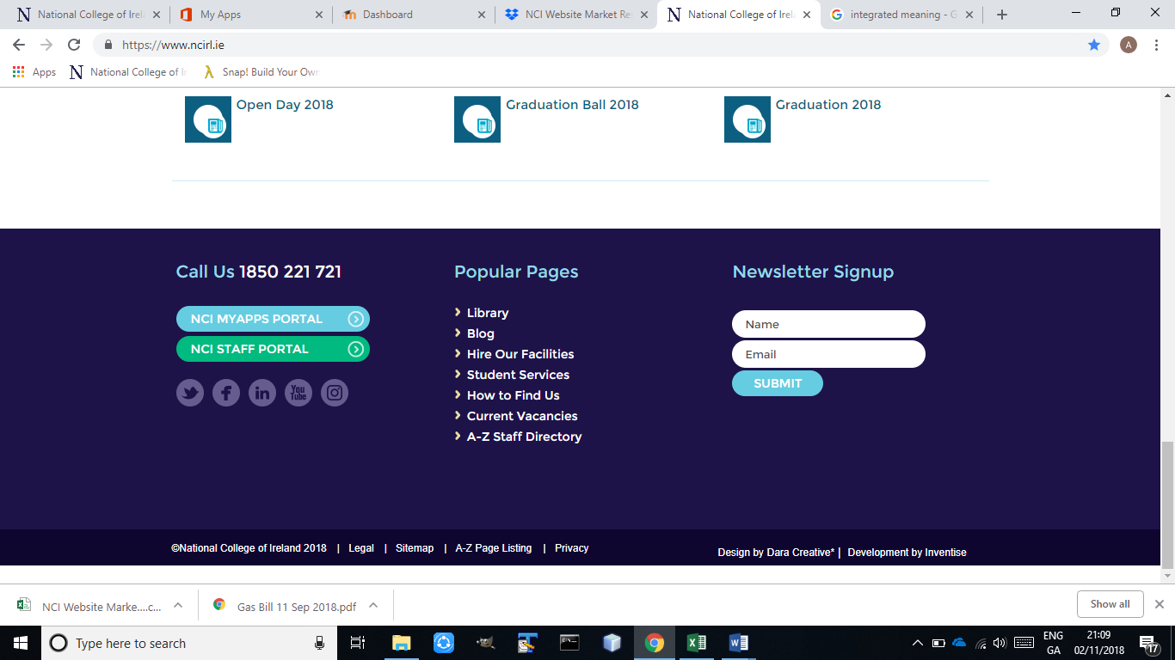

We will try to make it better and easier to use.

* Features like least by Students and Staff of NCI web page

1. Navigation Bar (No point to make 2 Nav Bar): - It confuses a user that 2nd Bar is the sub bar of the 1st one. It creates difficulty for every new user to find some information. Home button should be at the start of 1st left hand corner of nav bar.

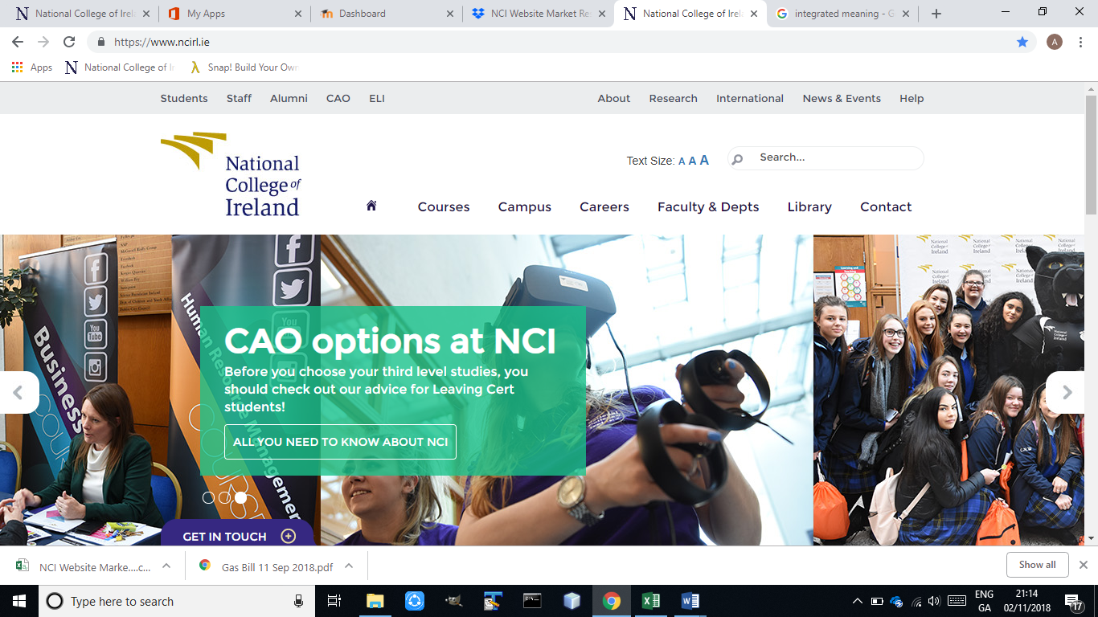

1. Content looks to cramped when viewed from Mobile: - As we can see that mobile view is too compressed, it’s very Hard to find Navigation Bar, student link etc. Everything is inside Menu button. The worse thing is all the information and context are upside down (very difficult to understand sequence).

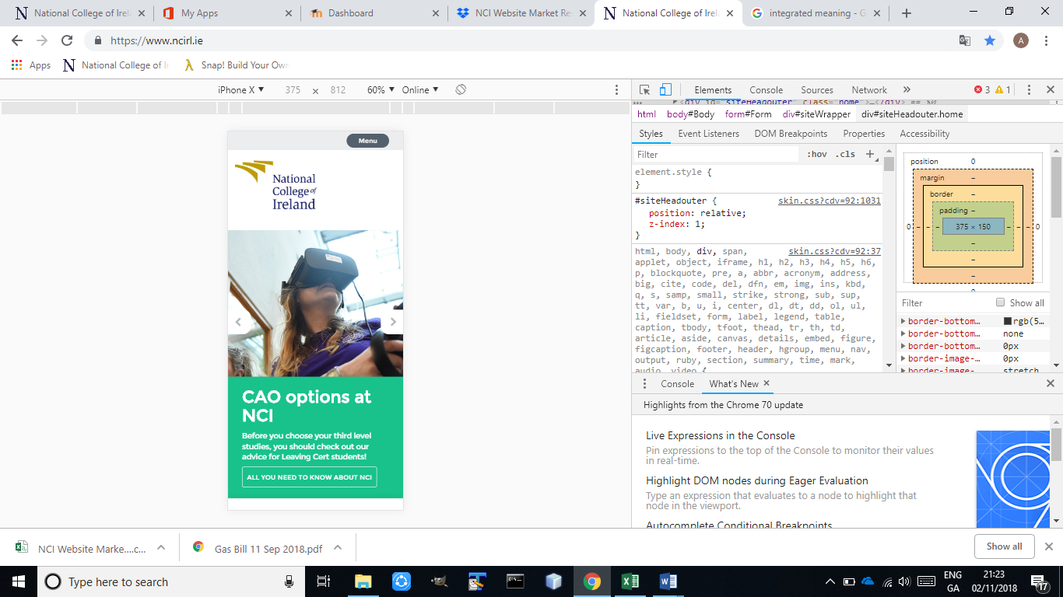

1. Search Bar is very old fashioned, difficult to see. For those users who have weak eye sight, its great problem for them to find and search information through search Bar.



* Suggestions to make NCI web page better

1. Simplify navigation (Discriptive and easy to use)
2. More user friendly (Attract users)
3. Re size image and content when using mobile devices (proper arrangements of both)
4. Remove old and unnecessary information(Will gives enough free space for more important contents)
5. Modify layout
6. Direct and prominent access to Moddle, citrix and office.
7. Increase traffic capasity size.

* Average Score is 6.5 out of 10.
* Competitors of NCI Web page

1. UCD (Better user Experience)
2. DCU (Faster loading speed)
3. DIT (Easier use, more informative)
4. ITB (Better navigability)
5. DBS (Better Layout)

* Need Direct access to Virtual Desktop (Citrix), OneDrive, drop box, Microsoft Office and Moodle.
* Make Moodle login link prominent at home page in Top right-hand corner.
* Most students have issue to check their previous year's results. Means a student can only see his results of current year only for 2 or 3 months (during summer break) until the start of next year. At next year he doesn’t have any access to last year's results. All this happens once a student register into next year of course (pay his full fee or 1st installment). The best solution is, results of all years should be available to every current student until the completion of his course. So, he can access it when and where he wants to improve his grades. And the other solution is NCI web page will allow students to download their results, so they check their marks any time.
* Paying fee and checking results are under My Details section. New students, most of the time face difficulty to find where this link is and for what purpose it uses. And this web page is very old fashioned and difficult to use. Its layer out and functionality was not updated sine 2014. Mostly it shows error message in codes. It’s impossible to understand to what that code means.

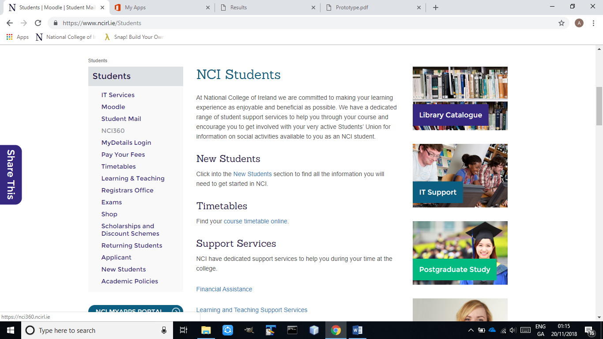

* Students can pay their fee online under My Details section but only for first time. Means each student can pay his fee online only for very first time at start of every year. So, either all students will pay their first installment or their full fee online and for rest they need to go to fee office to pay their remaining installments throughout the year. As we know, these days everyone wants to do everything online. They don’t want to go to offices, stand in que and wait for their turn to come. All this because no one has time to do new things, something more than daily routine. That’s why mostly students especially International students wants to pay to their all installments online under My Details section instead of going to fee office. This way is much easier, faster and safe. So, they can pay their fee whenever and wherever they want before the due date.

**Business Rules Analysis**

Here are the existing rules of NCI: -

1. **Library**

* Mobile phones should remain silent, if they are in library.
* Talking and whispering are not allowed because you may distract other students from their work. And it's against the discipline point of view.
* On one can sit in library or even enter library without his valid student card. This rule is because security reasons. No one from outside of college can enter or do his work by using college resources.
* Scanning Documents is free but for printing student need to pay € from this student card. 8 Cents are for B/W printing and 50 Cents for color printing per page and its compulsory.
* Every student need to top-up its student card online through NCI webpage. College is not accepting cash any more. That money student can only use for printing.
* Before exams, library is extremely busy. No one can sit for longer time because everyone wants to study in library. That’s why no one is allowed to sit longer then decided time and if you are using desktops it automatically switches off after 20 Minutes.
* Library is also providing 3 meeting rooms for students group projects, meeting, discussion and working on projects. But to avail this opportunity you need to book this room first then you can use that room.

1. **Fee department**

* Its compulsory for every student to pay his fee on time but need to pay all installments before the exams of 1st  semester of every year, otherwise students are not allowed to sit in exams.
* International students need to pay their first-year fee in one go. Installments are not allowed.
* Students can pay their first installment online but for rest they need to go to fee Office, down at the Atrium during their working hours.
* NCI is not accepting cash any more. College accepts fee only through credit or debit card, Bank drafts and transfer online to college bank account.
* If someone is transferring his online to college bank account then he needs to send the third-party receipt to fee office with his name and student number then college will know clearly who transfer that money, why he transfers and how much he transfers.
* If Student lost his student card, he needs to pay € 25 for the new one.
* Student need to pay some money if he Fails and to repeat that module.

1. **International office**

* International office is specifically for the queries of international students only.
* If someone wants to go International office, its compulsory for him to go between their working hours.
* Students will get their attendance record from there, but they need to tell them at least 2 days before since when they need.
* Students also need to request before, when they need visa renewal letter, PPS letter, Back Account letter, student job letter and others.
* If International students have some issue, they simply need to go to International office without going anywhere else because only that office have their full record.
* If you go to International office, you need to behave properly and talk to them with respect. Knock the door first and check if they are free, if they are not then writing your query in paper and drop into query box and then visit later.

1. **Moodle**

* Every student need to login first to access all his lecture notes.
* All new students need to reset their passwords once they receive their student ID with temporary password.
* Its compulsory for every student to reset his temporary password given by college for security reasons.
* Student need to pay his 1st year first installment, then we will get his Student ID from the college in order to access it.
* To login into Moodle student need to write his full student email for example [xStudentNumber@student.ncirl.ie](mailto:xStudentNumber@student.ncirl.ie).
* Student is enabled to access Citrix (Virtual desktop) once he successfully logins to Moodle. To login to Citrix he needs user name (xStudentNumber) and password.
* If a student forgets to sign out from Moodle, it automatically signs you out after a small interval of time.
* Its compulsory for every student to submit his project, CA’s etc. at least 2 or 3 Hours before the submission time. Because hundreds of students accessing that webpage at a same time.
* Through Moodle students can access their last years modules, their resources and grades. This thing help’s them a lot, to revise all the basics in order to understand advanced things properly.

1. **Attendance**

* Every student needs to be on time to attend lecture.
* Attendance time will start 15 Min before from every lecture. Its compulsory for everyone to tap his student card when he enters in room for the attendance.
* If someone has health issue or some important work that he can't leave. Because of it he is not able to attend college. It's his responsibility to show some solid proof to Attendance office that he is sick or busy somewhere. Then college will be able to consider it as LEAVE instead of ABSENT.
* If your Attendance is less then approx. 50%, you are not allowed to sit in exam because throughout the semester you didn’t follow the rule of Lecture, college and attendance. And if that kind of students will sit in exams it's not fair for others who attend all the lectures.
* That students don’t take interested in their studies and they also disturb and distract rest of class from their studies.

1. **Exams**

* Firstly, each student needs to clear his full fee before the exam day.
* Secondly, his attendance percentage needed to be above 50%.
* Mobile phones, Smart watches etc. are not allowed during exams. Because student may store some related information about exam paper in it and can search online about question that are in exams.
* Book, piece of paper, notes etc. are not allowed. Student need to leave all these things somewhere outside the exam room.
* Students are not allowed to leave the exam room in first and last 30 minutes of exam time. This is because to save student from cheating.
* For water, student No need to leave exam paper and room. College staff will serve water to student desk. It saves student exam time and from distraction.
* Every student needs to be in exam room at least 10 minutes before the exam starts. It helps him to find his seat easily, fill all exam requirements before the time starts then he can avail his full time just for exam.
* Once a student handed his exam paper to the instructor and leave the room then he is not allowed to sit again in exam even not to enter in that room.

1. **Lecture rules**

* Every student needs to be in class at least 5 minutes before the lecture starts then he can easily login to college system and tap his student card for the attendance. Because it’s against the respect of professor that he is teaching and after some time few students enters class and start asking questions about what they missed. This thing wastes time of other students. It also very hard for late commers to understand rest of the lecture. Because whole lecture is based on first 15 minutes and sometime professor give some important tips about exams or CA’s at start of the lecture
* Late commers create disturbance and distract rest of the class by their moments. This thing creates problems for professor to get their (Students) attention back to studies.
* Its great practice for Students to come on time for their professional life.
* When lecturer is delivering lecture, students are not allowed to talk each other. Students just need to focus on their studies and do what lecturer ask you to do.
* If lecturer, ask some question to the class its compulsory for each student to put their hand up and then give answer if lecturer ask him to give answer.

**Issues with rules and their Solutions**

* On one can sit in library or even enter in library without his valid student card.

**Solution**

If by mistake student forget his card at home and he want to study at library. He is not allowed to sit nor even enter library. To solve his issue college will give him temporary card. It will work same as his real student card. It is valid for that day only. Next day its compulsory for him to bring his real student card.

* International students need to pay their first-year fee in one go. Installments are not allowed.

**Solution**

As we all know, International student already spent too much money for his visa, travel tickets, hostel, admission fee etc. it’s very hard for him to give his full year fee at once before the college start. And at that time, he is not working and, he already spent all his saving. So, its college job to help them by allowing to pay their first fee in installments. In this way college will become more popular and more students will get admission at NCI because it’s very good technique to attract International students.

* If Student lost his student card, he needs to pay € 25 for the new one.

**Solution**

College need to charge some money as a fine for the loss of student card. But € 25 is too much. Human make mistakes. College need to reduce this fine. Most students said fine need to be between € 10 - € 15. Because the cost of student card is not that much high that students need to pay € 25.

* Late commers create disturbance and distract rest of the class by their moments because professors allow them to sit in class.

**Solution**

Most of the Lecturers agreed that whoever come after 25 minutes of lecture time, he is not allowed to sit in class. Because that type of students is not interested in studies. They just come to pass their time and distract other students and professor from their studies and their goals. If one day student is late due to huge traffic jam or some other genuine reason that ok, but habitual of being late is not right and not to take interest in his studies is more worse thing. That type of student’s case problems for college.

* Moodle crash during CA’s or Assignment submission time.

**Solution**

It is one of the biggest problems that every student face during submission time. Its not a good thing as business point of view. Competitors can use this as our week point. Moodle is not able to hold that much traffic yet. We should need to talk them to increase our traffic size then students will not face this issue. For this college need to pay more to Moodle and is worth to pay more for this problem. Because sometimes when Moodle crash students can lose this file as well. Then we can use this thing as one of our strategy to attract more students every year. That types of issue are not good for one the leading colleges.

# **Planning, Conducting and Documentation Progress for rout cause analysis and swot**

**Root Cause Analysis**

First documentation: first face to face meeting with team and stakeholders:

NCI Problems statement stage 1:

|  |  |
| --- | --- |
| **Team opinion**  A. broken links  B. outdated navigation  c. Difficult to find information  I. student can’t see previous year results  J. Moodle crashes  k. citrix crashes | **Stakeholders opinion**: vector(student)  E. poor layout  F. difficult to find info  G. late updates for the system  H. broken links |

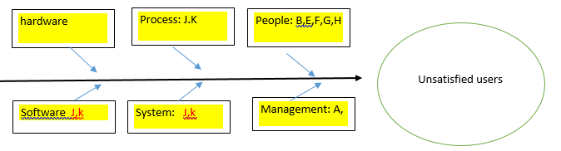

***Chart Source BABOK (2015)***

Second documentation: second meeting with team using market research questionnaire:

NCI Problems statement stage 2:

|  |  |
| --- | --- |
| **Team opinion**  1. broken links  2. outdated navigation  3. Difficult to find information  4. student can’t see previous year results  5. Moodle crashes  6. F. citrix crashes | **Stakeholders opinion from face to face meeting**:  7. poor layout design  8. late updates for the system  **Stakeholders opinion using questionnaire:**  9. Difficult to access info  10. The content looks to cramped when viewed from mobile.  11. Poor design  12. Slow connectivity |

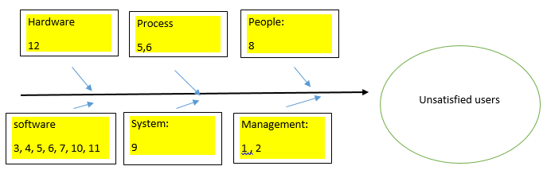Fishbone diagram used from BABOK.

After collecting the necessary data from stakeholders and organize all problems into 6 different categories, we decided to start using the 5 whys method to help us collect more information about each of the identified problems and find common roots between the stated problems

**The output of the 5 whys method is as follow:**

|  |  |  |  |  |  |  |
| --- | --- | --- | --- | --- | --- | --- |
| problem | Who? | What? | When? | where? | Why? Num1 | Why? Num2 |
| 1 | management | Broken links | monthly | Website Internal links | Delete, rename or remove content by accident | Poor management work performance |
| 2 | management | Outdated navigation and information | monthly | internal | Delay to change information on website | Poor management work performance |
| 3 | Software | Difficult to find wanted info | continually | internal | Website Not user friendly | Poor Design planning and testing |
| 4 | Software | Student can’t see previous year grades | continually | Moodle | No exited function to see previous grades | Poor Design planning and testing |
| 5 | Software | Poor Moodle performance | continually | external | Server/memory problems | Poor Network /hardware installation |
| 6 | Software | Poor citrix performance | continually | external | Poor connection between end user and citrix environment | Poor Network /hardware installation |
| 7 | Software | Poor layout design | continually | internal | Website Not user friendly | Poor Design planning and testing |
| 8 | people | Late update for the system | continually | internal | Delay to install updates for the system | Poor work performance |
| 9 | system | Difficult to access information | continually | internal | Not user friendly | Poor Design planning and testing |
| 10 | Software | website do not look good using mobile | continually | internal | Users access website from browsers | No website App |
| 11 | Software | Poor design | continually | internal | Not user friendly | Poor Design planning and testing |
| 12 | hardware | Slow connectivity | continually | internal | Server/equipment problems | Poor Network /hardware installation |

**Fishbone Diagram, market research and 5 whys Results:**

Output from the 5 whys results:

We calculated the total amount of identified problems, and to total amount of common causes, the result is as follow:

1. Poor management work performance: 4 repeated root cause /12 identified problem = 0.33*100= 33%
2. Poor Design planning and testing: 5 repeated root cause/12 identified problem  
   0.41.66*100= 41.66%
3. Poor Network /hardware installation :3 repeated root cause/12 identified problem=  
   0.25*100=25%
4. No website App: 1 repeated root cause/12 identified problem= 0.833*100=8.33%

|  |  |  |  |
| --- | --- | --- | --- |
| Total Problems | Total problem rout causes | total of repeated root cause in the 5 whys report: | % |
| The Project team ends up with the total of 12 problems | The project team summaries the causes of problems in 4 principal areas:   1. Poor management work performance 2. Poor Design planning and testing 3. Poor Network /hardware installation 4. No website App | 4  5  3  1 | 33%  41,66%  25%  8.33% |

**The following diagrams presents the obtained values from the Analysis:**

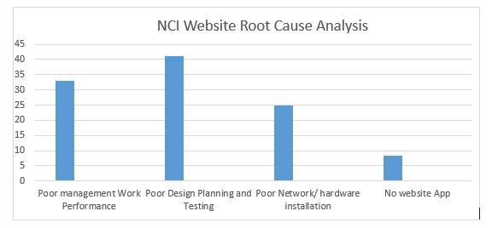We can see from the chart, the Poor design planning and testing takes the highest percentage between all other causes, the team will focus first on finding appropriate solution to enhance the design of NCI website and apply testing before development, our team goal at this stage is to provide better user experience for NCI users.

The team member agreed on choosing the following solution for all 4 main problems at the beginning:

**Starting the Selection of Solutions:**

|  |  |
| --- | --- |
| NCI website Root causes problems | solution |
| Poor management work performance | Provide training for staff  Enhance communication performance in management department |
| Poor Design planning and testing | Use prototyping before starting development  Include stakeholders in design process  Make Changes in the NCI website design |
| Poor Network /hardware installation | improve network and hardware installation |
| No NCI website App | Create NCI website App |

We will review the proposed solution and analyze it in future meeting and also get feedback from stakeholders and make changes before deciding the final appropriate solutions for the project.

**Extra Analyze and try to reach the reel cause of the 4 main problems:**

**Starting Detecting the root cause of the 4 main problems existing in NCI website:**

|  |  |  |  |  |
| --- | --- | --- | --- | --- |
| problems | Why | Why | Why | Why |
| Poor  management work performance | Lack of supervision  and monitoring | Lack of communication  skills | Unclear  goals  and duties | ? |
| Poor  Design planning and testing | Website design  do not meet  users'  requirements | Not involving  reel website users  in planning  phase | Organization  focuses  on goals  rather than  users’ needs | Poor decision making about the site design |
| Poor  Network/hardware installation | Imperfect  network design and equipment | Poor  decision  making about  Suited  hardware and network |  |  |
| No NCI  website  App | Organization  goals do not  focus on  creating  website app | Organization thinks  it’s not  necessary | NCI  Budget problem?? |  |

**SWOT**

After the first meeting with team we collected the necessary information under each of the 4 main categories of Swot template, the results were as follow:

**First documentation:**

|  |  |
| --- | --- |
| **Strengths:**      **Matured website.**      **Social media integration:**  Increase awareness of NCI website content and the ability to increase user experience    **Features:**  Fresh and useful content  Fast and simple logout process  **Security:**  High level of security for student’s data  **Good content:**  NCI website provides high quality and well written content that provides value to readers. | **Weaknesses:**    **Not the best website quality:**   1. Poor hosting service 2. Poor design layout 3. Long navigation process 4. Poor user experience 5. Poor mobile optimization 6. Confusing website structure     **Poor equipment and network installation:**  Moodle and citrix Users find continuous connectivity problems due to inappropriate equipment and network installation. |
| **Opportunities:**  **Market development:** to be discussed in next meeting    **Improve user experience:**  Use Latest design trends  Create NCI mobile App | **Threats:**    **Financial pressures:** to be discusses with stakeholders    **Website hacking:**  Hacking leads to serious impacts such as website confidential data lose and stealing  If it’s the case, the NCI website may experience Downtime that will damage reputation of NCI website and results lack of user's trust, also it can be expensive to clean and repair the website.    **Strong competitors** (data collected from market research):  competitors like DIT, DCU, DBS and ITB provide better services such as better user experience, better Moodle and citrix connectivity. |

SWOT template used from BABOK

We will review the swot template with stakeholders in future meeting and make changes depending on stakeholder’s feedbacks.

**Market Research and Benchmarking (J.Smith)**

The data produced from our market research was going to be important not only to the project itself, but it was also going to be important to my fellow team members for use in their chosen techniques. As the project team, we all had our own views of what we wanted to do but we also wanted feedback from outside of our team. It was important that we obtained feedback from as many different categories of stakeholders as possible. We wanted to get feedback from people who used the NCI website as students and also as members of staff. We also wanted feedback from people of different age groups and nationalities and differing levels of technical ability. As a result of a group meeting we decided that the best way to obtain data from such a wide variety of sources would be through a questionnaire.

The questionnaire could be placed online using “Google Forms” and could be freely accessed by all stakeholders who wished to take part. Google forms would then collect the resulting data from the questionnaire and present it in a meaningful format for us to use. Google Forms would also make the data available in spreadsheet format so that it could be uploaded to the rest of the team for analysis and use in the team’s other techniques really quickly. A draft questionnaire was first written with a list of questions that I wanted answered and then uploaded to the team’s folder where the other members could add any other questions which would produce the data relevant to their techniques. It was important to format the questionnaire in a way that it was easy to fill out and yet still obtain the relevant data. To achieve this, a combination of user-friendly checkboxes and multiple choice questions were used.

The results of the market research questionnaire are listed below.

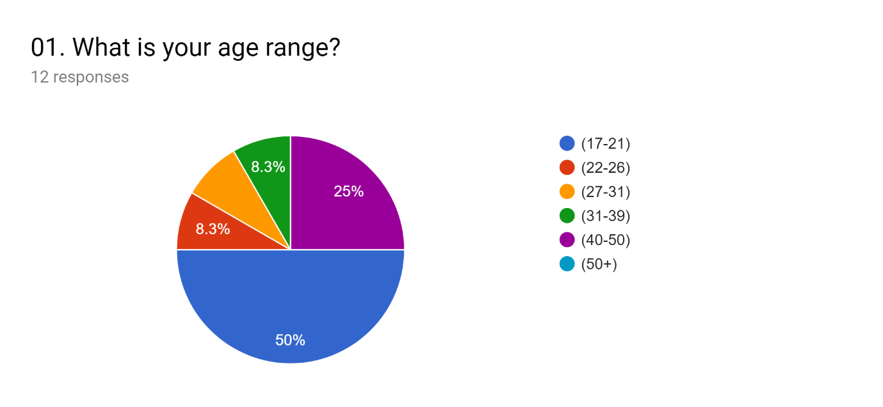

Q1 confirmed what we expected which was that a lot of the websites users were between the age of 17-21 but there was still a healthy diversity in other age brackets which made up the other 50%.

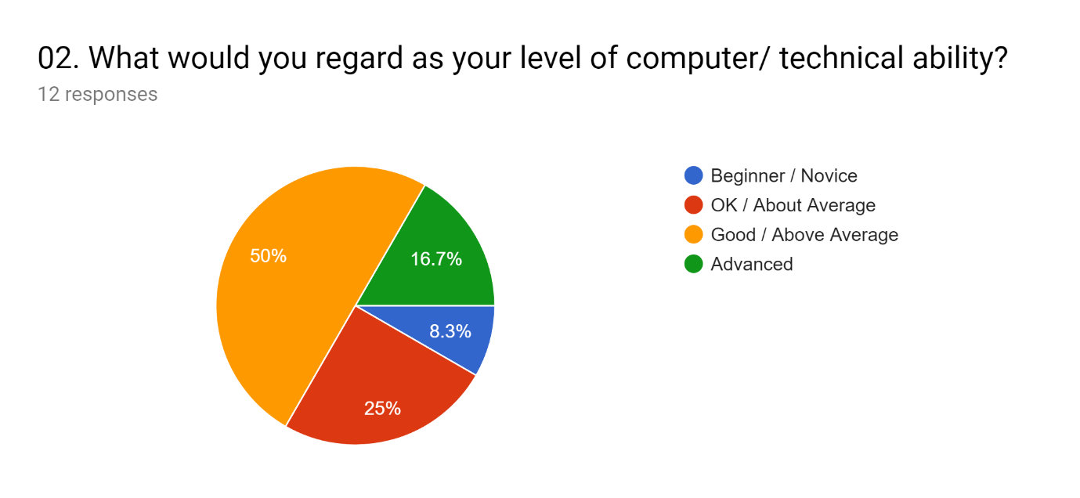

Q2 Showed that there was also a diverse level of technical ability in the stakeholders. 66.7% described themselves as advanced or above average which indicate that they would be familiar with web technology and able to highlight problems or areas of improvement. 8.3% described themselves as novice users and 25% as average ability so it was good to hear feedback from their user experience and any problems that they faced too.

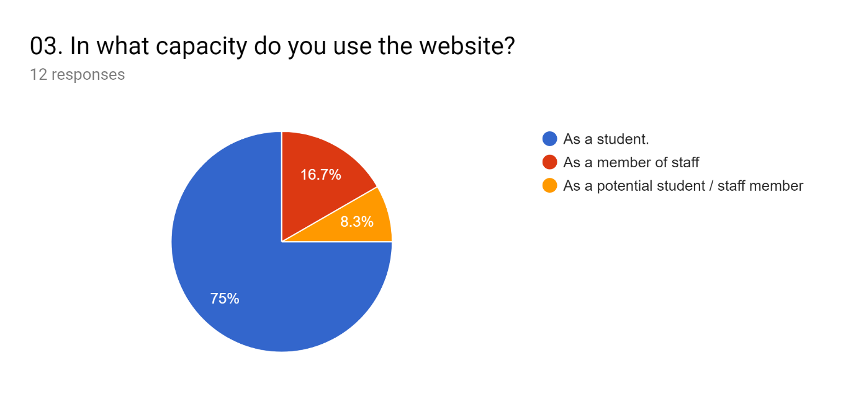

Q3. Showed that 75% of the websites users were students while 16.7% were staff members and 8.3% were potential staff members or students. This confirmed as we had expected, that most of the websites users were students which made up a large percentage of the stakeholders but that we also had the opinions and feedback from staff members and potential students who were also users of the website and therefore also stakeholders.

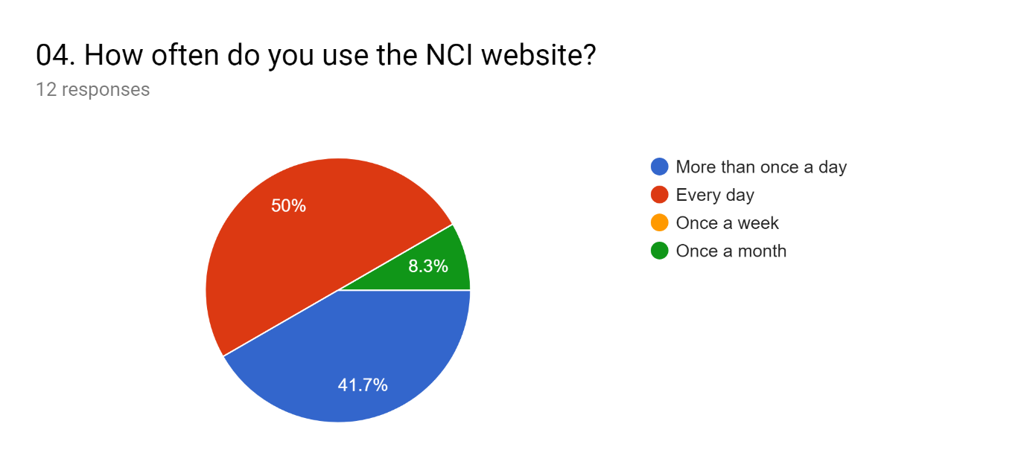

Q4 Showed that a huge majority of the websites users used it on a daily basis. With 91.7% using it at least once or more than once each day. This data will be useful when considering issues like bandwidth for the project.

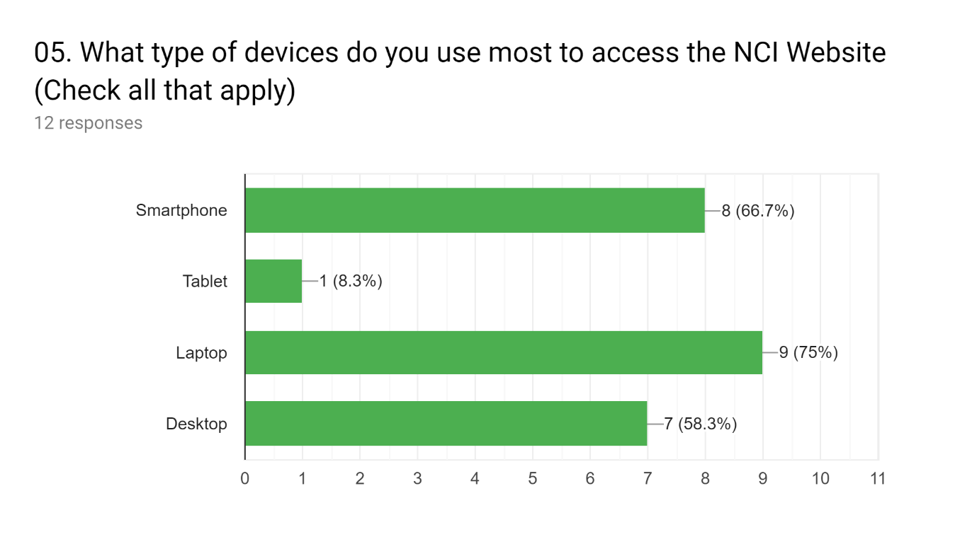

Q.5 Showed that the website was viewed using a variety of devices which used all different screen sizes. This would help the project team to make decisions when it came to issues like responsiveness and layout.

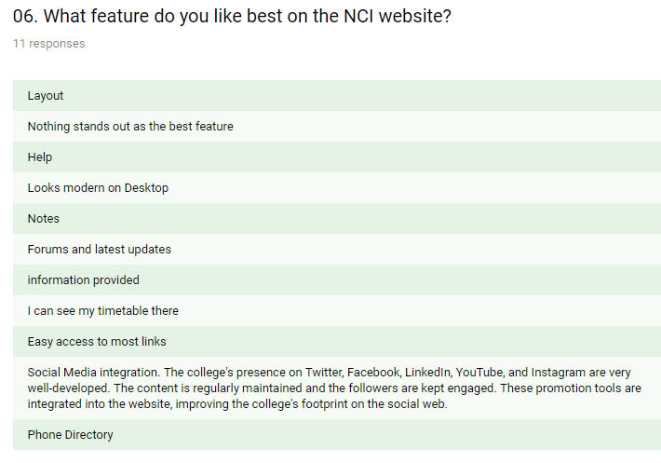

Q.6 allowed us to gather data on the features people actually liked on the NCI website. The responses were quite varied with no feature in particular being favoured by a majority. There was some interesting points regarding social media integration and access which could be retained going forward.

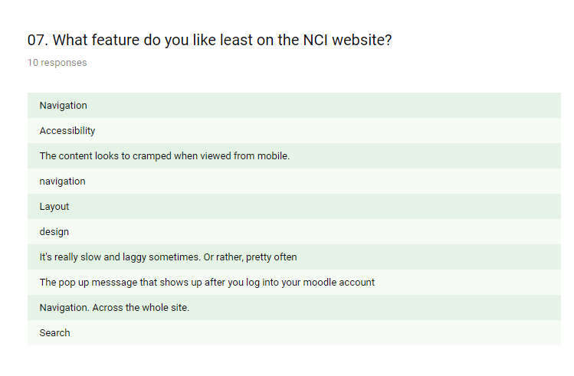

In Q.7 when asked to describe what they did not like about the website the responses indicated, Layout, Navigation, Design as the most prominent issues. These areas will be of interest for us going forward with the project.

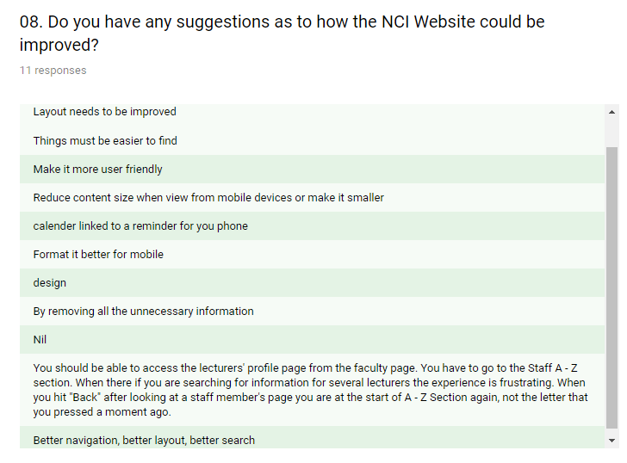

In Q.8 when asked about suggestions to improve the website, the responses were similar to the previous question with people just saying things like improve layout or better navigation. There was a good idea about a calendar linked to a reminder on your phone. There was also some good feedback from staff regarding improvement for access to the lecturers’ profile page from the faculty page. These options should certainly be considered as part of any website revamp.

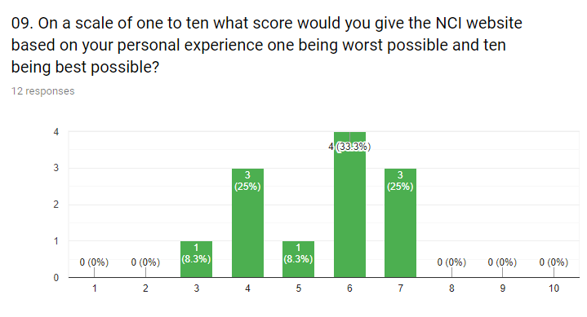

In Q.9 people were asked to rate the NCI website on a scale of one to ten. A total of 58.3% scored the website above the median value of five. This result was interesting because it suggested to me that the majority of people did not dislike everything about the website and that they actually liked more than they disliked. This also suggested that not everything would need to be started from scratch.

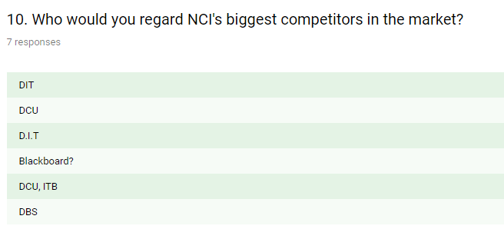

When asked who they regarded as NCI’s biggest competitors the responses were:  
DIT, DCU, DBS, ITB

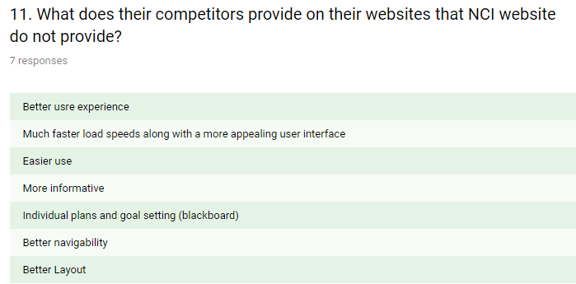

When asked what these competitors provided that NCI could improve on, the answers again weighed towards better user experience, navigation, layout. There was also a suggestion of a plans and goal setting feature like “Blackboard”

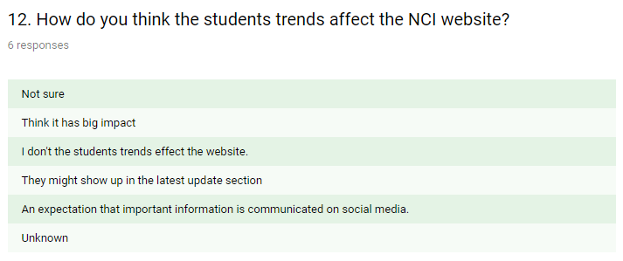

When asked how they thought student trends affect the NCI website participants gave a very mixed and contrasting response. Some said that they did not feel like it impacted at all whereas some said that it had a big impact, and some were not sure. There was also the suggestion that important information is posted on social media and also that they might show up in the latest update section.

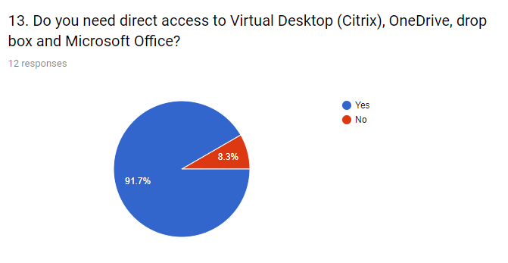

When asked if they need direct access to virtual desktop (Citrix, OneDrive, DropBox and MS Office) the response was unanimous.

91.7% said Yes  
8.3% said No

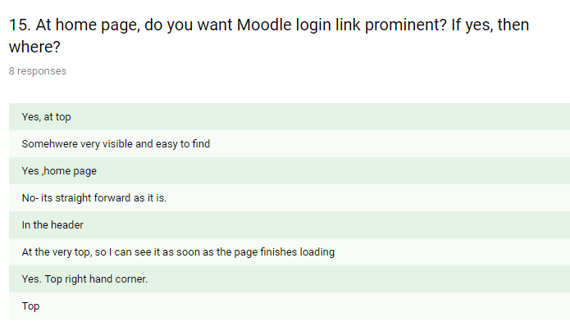

When asked if they thought the Moodle link should be more prominent a large majority of users favoured it being at the top of the page.

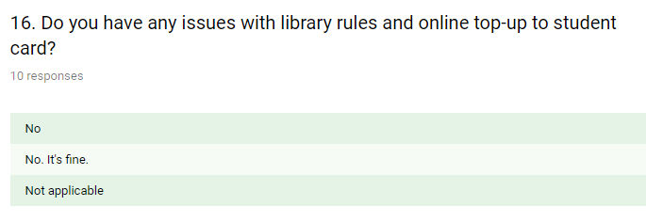

When asked if they had any issues with the library rules and online student top-up card the response was NO

With the data from the market research we now had a much clearer idea of what the other stakeholders required. The results of the market research questionnaire suggest that the entire website would not need to be redesigned from the bottom up again. The website does not rely heavily on graphic images and instead uses photographic images of students at the college. These images were only recently created and would not need to be changed. The content and information on the website is very relevant and people had not complained about it at all so this also would not need to be changed. However people clearly have issues with how this content is arranged and how they access it. So two areas to look at would be Layout and navigation. Now the rest of the team had some data to work with and enough information to start work in analysing the data further and preparing a prototype.

**Benchmarking: (J.Smith)**

Some of the data collected from the market research involved feedback from stakeholders involving websites belonging to NCI’s competitors. These competitors were listed as

* Dublin Institute of Technology (DIT)
* Dublin City University (DCU)
* Dublin Business School (DBS)
* Institute of Technology Blanchardstown (ITB)

Each of the above websites were checked to see how their best practices compared to those of NCI. As we have seen from the market research that we conducted, the areas of most concern to us were navigation, layout and user experience. The real stand out performer when it came to user experience and performance was Dublin Business School (DBS). Their use of JavaScript dropdown menus produced a fast and snappy experience and also looked great. The menus appeared as soon as you hovered over them and immediately dropped down to display further information. This was superior to the technique used at NCI where the dropdown menus ghosted into place or DIT where you had to click the menu before it dropped down. The worst performer in this field was ITB which provided a static, dated navigation system with no dropdown menus at all. So although NCI’s website was not the worst in the field for navigation it could be definitely improved by emulating the dropdown navigation system of DBS.

Navigation and the ease of finding information was another issue highlighted by a lot of stakeholders. Once again, NCI was not the worst when it came this area. Again, the worst case was ITB which provided static links in which a user has to click courses, then computing then full-time courses then your choice of course. There was no dynamic experience provided at all. NCI, DCU and DIT provided an improved system and were very similar in this area where the information was available on the website, but it still required more clicks than it should have to reach it. DBS again provided an example of much better practice here. To repeat the example used above with accessing information on courses, on the DBS website you only have to hover over the Courses tab and a dropdown menu instantly displays with a choice of available course faculties like Accounting, Arts, Business Management etc.

The final area of interest to us was Layout. This was another area highlighted in our market research feedback. The websites that we looked at provided mixed results in this area. Some websites like DIT and DBS had a bit too much information available on the landing page. Others like NCI and ITB had too little. The website that found the best balance in that area was DCU. The DCU website has all of the important links in the navigation bar at the top of the screen which can drop down if selected to access further information. They then have a main photographic image under this with some more links in the form of coloured tiles. Then there is relevant news and information displayed in the form of text and images in a grid styled display of three columns and four rows. The social media and contact information then appears at the foot of the page. This presents just the right amount of important information up front in a visually appealing format without appearing cluttered. If NCI were to adopt this practice along with the others recommended above then it would provide a much better user experience and also address the issues with layout, navigation and easy access to information. There should also be a more prominent link to Moodle at the top of the homepage this is a feature that none of the competitors have yet implemented and therefore would actually be unique to NCI.

**Market Research (Phase II)**

Once all of the data was collected from the market research and benchmarking it was then provided to the rest of the team to be used within their various techniques. Then we had a team meeting and examined the data and our results before deciding that we had made enough progress to create an initial prototype which could be shown to the stakeholders. My colleague Umer then took all of the ideas and recommendations that we received from the stakeholders and produced our first prototype. The prototype was then published online for students and stakeholders to view. Another market research questionnaire was published along with the initial prototype so that stakeholders would not only have the opportunity to view the prototype, but they could also provide us with valuable feedback. This feedback would then provide more data which would be used to make further improvements. The results of the feedback can be seen below.

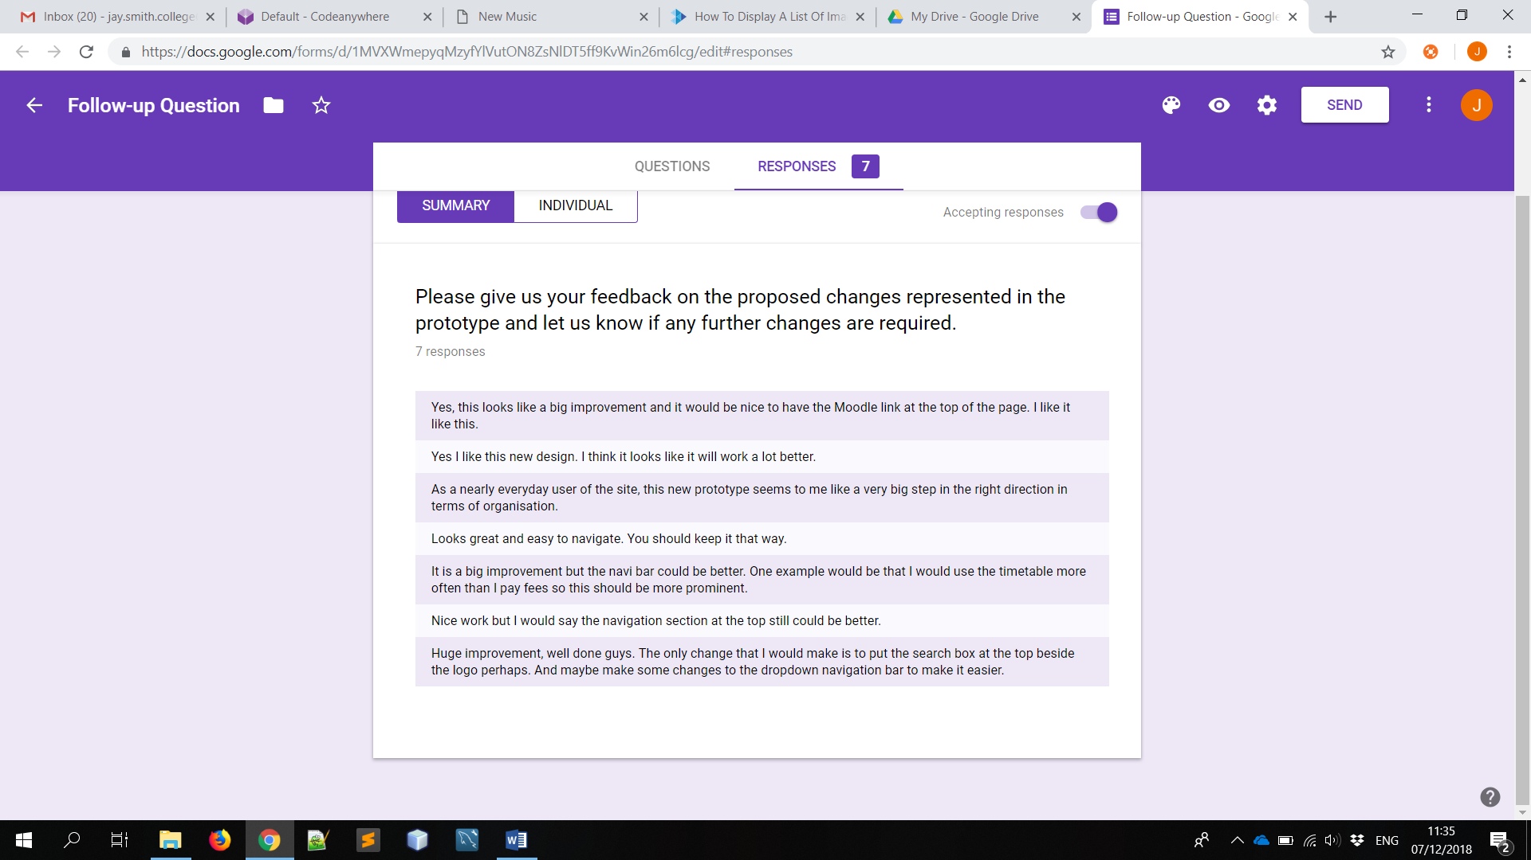

The second round of feedback from the stakeholders indicated that the team was on the right track and that the prototype showed a big improvement over the original website. Some stakeholders did express concerns about the navigation system and relocation of the search feature and this was an area that would need to be re-examined. This feedback was then discussed with the other team members in an attempt to implement possible changes in a second prototype which could be returned to the stakeholders.

A new prototype was then created which included some changes to the navigation system and the relocation of the search feature. A new survey was placed online and stakeholders were provided with a link to view the prototype and invited to leave any feedback through a web form. The response to the new prototype was very positive and the results can be seen in the screenshot below.

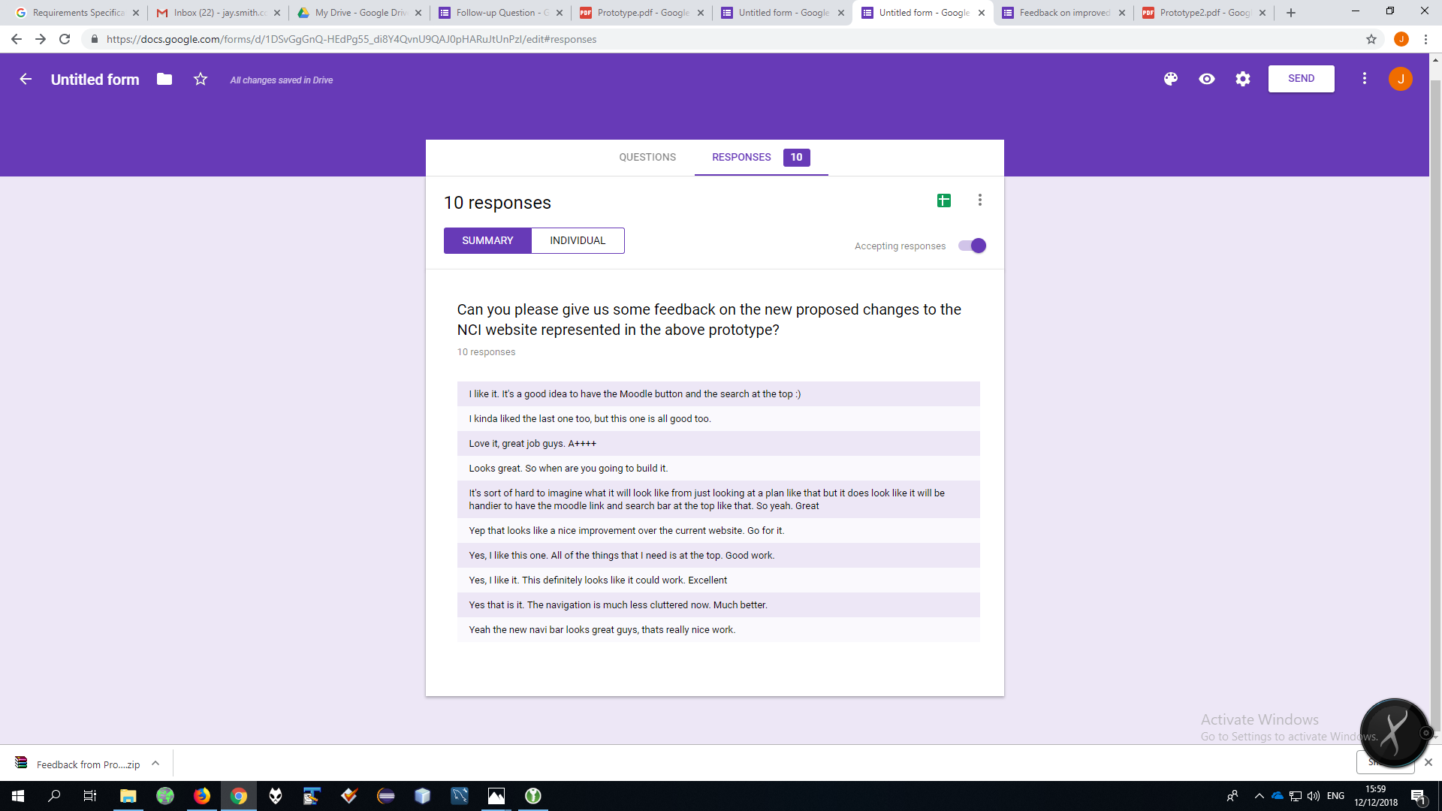

The results indicated that the stakeholders were now happy with the changes which were proposed and displayed in the new prototype. The team now had all of the data and feedback from the stakeholders and also a visual representation of the work that needed to be done.

So in conclusion to the Benchmarking and Market Research

* The navigation system on the current NCI Website needs to be completely redesigned to provide a similar or better user experience compared to best practices currently in use by competitors in the industry.
* The layout and organisation of content must also be changed in order to provide a better user experience to the website users. The content itself is fine, but it must be structured and organised much better.

**Estimation (J.Smith)**

Estimation is an important part of the project because it involves getting a detailed idea of the costs, resources and duration of the project. In fact it would not make sense to even consider working on a project without first having an idea of how long it was going to take to complete and secondly how much it was going to cost. The result of the first round of Market Research & Benchmarking indicated that the NCI website did not have to be completely recreated from scratch. The content and images on the website was fine and so there was no need to have new content written. The website did not rely on graphical images that would need to be produced by a specialist or graphic designer. The images on the website were photographic images of students which were recently taken and could still be used on the updated website. The navigation and layout were the areas that people had the most issues with. Therefore, these were the areas that I would be considering in my estimations.

To replace the navigation system on the college website and then redesign the layout and then also re-instate the existing content and information from the current website I estimated that we would require two Web Developers (one of which is a senior), A Web Designer and an Accounts Manager. The accounts manager would preform the role of liaising between the development team and the stakeholders throughout the project. Now that the areas of the website that needed to be redeveloped had been decided the next step was to estimate the time that it would take and then the cost.

First, we wanted to estimate the duration of the project and how long it would take to complete each key phase. We looked at the five key phases of the project which were:

* Initiation
* Planning
* Execution
* Monitoring & Control
* Closure

These phases were then broken down into further stages using a work breakdown structure in Microsoft Project. This process allowed us to allocate a time frame to each sub task and also to see which tasks could run simultaneously. The scope, time and cost of the project is calculated more accurately when the project is defined in more detail. (Schwalbe 2015)

When the work breakdown structure was completed it gave the following durations of time for each phase.

* Initiation – 3 Days
* Planning – 20 Days
* Execution – 25 Days
* Monitoring & Control - 15 Days
* Closure – 1 Day

This gave a total time duration of 64 work days from the first day of initiation until the final day or the closure of the project. The timespan was from Monday 15 October 2018 until Friday 11 January 2019 which gives a total of 12 working weeks (Monday to Friday).

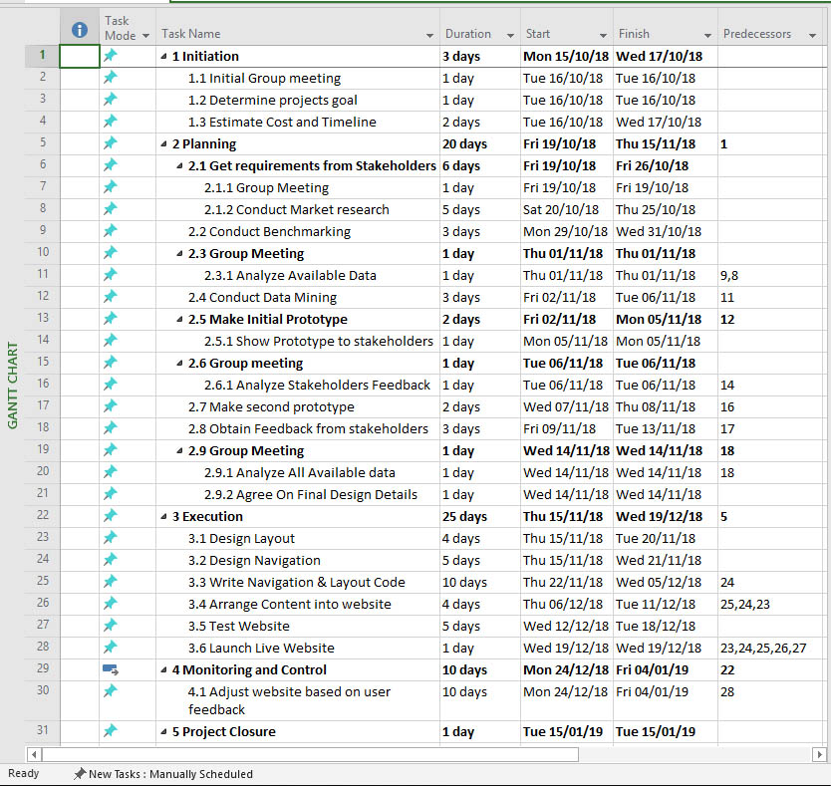

(Screenshot from the MS Project Work Breakdown Structure)

I then decided to use the Program Evaluation and Review Technique (PERT) to give us an average estimate by considering our estimate alongside both optimistic and pessimistic ones.

Program Evaluation and Review Technique (PERT) is a network analysis technique used to estimate project duration when there is a high degree of uncertainty about the individual activity duration estimates. (Schwalbe 2015)

PERT weighted average =

Optimistic time + 4 × Most likely time + Pessimistic time/6

So using our estimated time of 64 days from our work breakdown structure as the most likely time, we then added 10% for the most pessimistic time and subtracted 10% to give us an optimistic time the 10% of 6.4 days was rounded to 6 days.

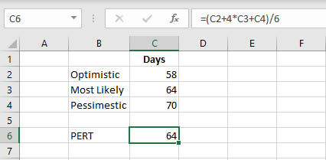

The PERT weighted average gave the same result of 64 work days as our estimation based on our work breakdown structure. (Schwalbe 2015)

The next step was to look at the cost of hiring the required personal to carry out this work over this duration of time. I had already estimated that the project would require two Web Developers (one of which is a senior), a Web Designer and an Accounts Manager. Now I would need to estimate the cost of hiring these four people over a twelve-week period. To do this I went to the Glassdoor.ie website to use their data as a source for my estimation. Leading financial news outlets like Bloomberg and Yahoo Finance regularly use data from Glassdoor as a source to produce estimates on things like changes to corporate revenues or the effects of salary trends.

The national average salary for a Senior Web Developer according to Glassdoor is €64,750

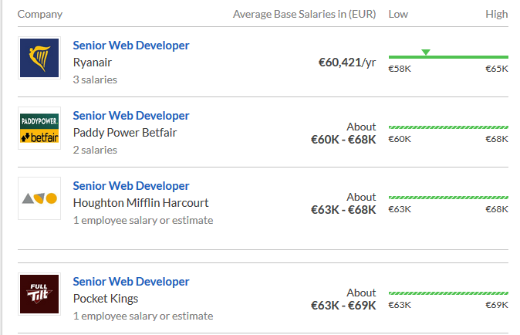

*Image www.glassdoor.ie*

The national average for a Web Developer is €40,784

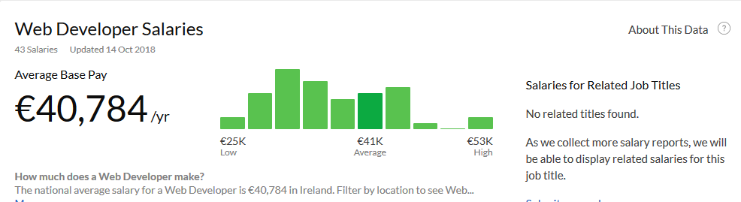

*Image www.glassdoor.ie*

The national average salary for a Web Designer is €34,000

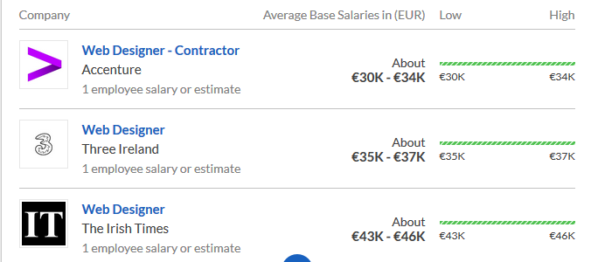

*Image www.glassdoor.ie*

The national average salary for an Accounts Manager is €40,000

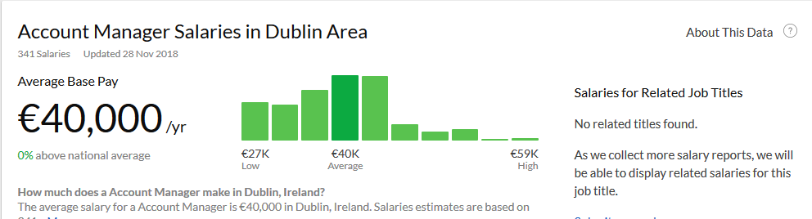

*Image www.glassdoor.ie*

I calculate the cost of hiring each team member by taking their annual salary then dividing it by 52 to get 1 weeks salary. Then I multiply this by 12, which is the number of weeks that they we want to hire them for.

Senior Web Developer €64,000 / 52 = €1230 then €1230 x 12 = €14760

Web Developer €40,784 / 52 = €784 then €784 x 12 = €9048

Accounts Manager €40,000 / 52 = €769 then €769 x 12 = €9228

Web Designer €34,000 / 52 = €654 then €654 x 12 = €7848

This produces a total of €40,844

**Estimation Conclusion / Outputs**

The project will require a duration of 12 weeks to complete. This is from the first day of the initiation phase until the point of closure.

The personnel required to carry out this amount of work within this timeframe will be a four person team consisting of a Senior Web Developer, a Junior Web Developer, an Accounts Manager and a Web designer.

The total cost required to hire these people for the 12 week duration of the project will be €40,844

**Planning, Conducting and Documentation Progress week 9 for rout cause analysis and swot**

Is this stage we planned to review all outputs, feedback from stakeholders and make changes to

1. 5 whys results
2. Swot results

**5 whys result after meeting and getting feedback from stakeholders:**

We started to do more research and analyse each category of the 4 detected problem areas using 5 whys, after documenting the first results, we established a review meeting to get feedback from stakeholders

The output of the meeting is as follow:

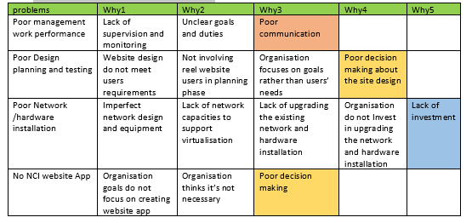

|  |  |  |  |
| --- | --- | --- | --- |
| Total problem categories | categories | Total repeated categories | % |
| 3 | Poor communication  Poor decision making  Lack of investment | ¼= 0.25*100= 25 %  2/4= 0.5*100 = 50%  ¼=0.25 *100=25% | 25%  50%  25% |

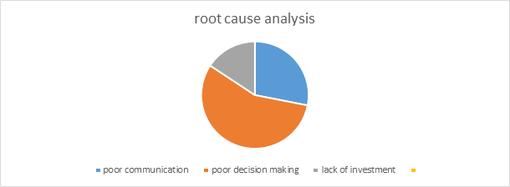

At the end of the analysis we discovered 3 major problems, poor communication, poor decision making and lack of investment. The lack of investment takes 50 % comparing to poor communication 25% and lack of investment 25%.:

**Swot results after meeting and gather feedback from stakeholders:**

I conducted a meeting with stakeholders to review the swot analysis results and collect feedback

The requested changes made by stakeholders are:

The stakeholders suggested to cover more areas in details and do more research in following suggested areas:

1. Market demand:

In order to explore the impact of market demand for NCI website services, I had to start with the quality of the service provided for the users. Using the market research data helped me to have better idea of user experience quality. 58.3% among 12 people who respond to the survey described the NCI website as median value of five out of ten.

This result explains the low demand for NCI website services, this can impact the value of the website and may impact the ability of NCI college to attract new students, as the first thing the future student do is navigating the NCI students before making a decision to register in NCI or another University.

1. Market development:

NCI needs to take advantage of the high demand for good quality website that meets users’ needs. And start planning for a market development strategy that covers low quality user experience in the current website and enhance it to attract more new students in the future.

1. Financial pressure:

NCI ability regarding expected expenses for funding new projects like enhancing NCI website and specially improving the network/hardware installation whiting the college. This financial pressure needs to be analyzed and managed in a better way, NCI needs to review the existing financial risk management and include the following areas in the new strategy to face similar financial risks that can have a high-level impact in NCI services.

The outcome after gathering feedback from stakeholders is:

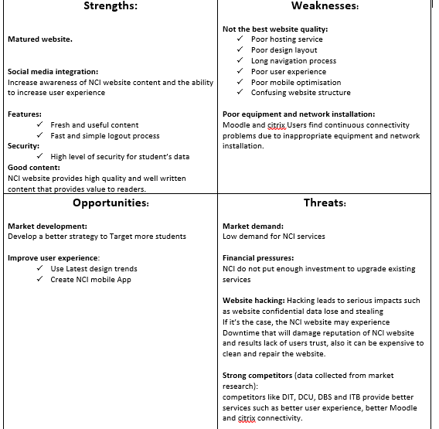

In Future meeting we are planning to review proposed solution and provide new solution for the 3 major areas encountered after conducting the 5 whys method.

**Fundamental Business Analysis Report:**

Data Flow diagram

The planning for doing this technique was to first research data flow diagram samples and do rough sketches, and have the diagrams reviewed so that I can correct any mistakes. For the plan I had to make use of the book BABOK for reference and to decided what level of diagram I will use.

The Data flow Diagram was the more difficult of the two techniques I chose as it took me a while to fully, understand it and in order to properly do a sample as the diagram can have multiple level, which breaks down the diagram even further. However, I had decided to keep it at level zero to not make it complicated. I used the highest-level diagram called a context diagram as reference that represents the entire system and again is the easiest for people to read and understand. The example I used is when users want to rent a book on the NCI website the diagram goes over the process and what happens at each step and who is involved. What happens is the user or students request to reserve a book in the library for lending and the system checks that book to see if it’s available to reserve which the admins or librarians will check if the book is available or not and send back the info to the user along with a date for return. I describe these actions using a Context Diagram Gane-Sarson Notation and I had to go into the website to understand find the library and see how the lending system works.

The diagram on BABOK simply shows how data moves in the system and is the basic overview of the entire system being modelled. I had to research many examples and for this technique, there were many types so finding a simple one for use took me a while. For feedback, I asked my PA to have a look and review both of my diagrams of the techniques. I asked him to list out his thoughts and he mentioned a few. The problems he came across on my rough diagram of the data flow was that the labelling. The layout of the labels was messy and unclear of what they were meant to be, for example if they were the process or the header. Another problem was the lack of use in colours to make the diagram stand out and easier to read. One last problem the PA pointed out was that the diagram was a bit smaller. In the end, I corrected these mistakes and went over the diagram again.

My problem then was how the diagram should look and what should it have on it, so I decided to go with a review other examples online and keeping the diagram on BABOK as reference as well. I did not need it to be big as the actions that occur were few to begin so it did not take long to come up with a few diagrams for rough drawing. After this, it became much easier to create the diagram as I had an image on BABOK to follow as reference. In the diagram, I wanted it to show how the user, library database, library page and admin all interact in the lending process and how the info moves around. The Gane-Sarson Notation was the best option to choose, as it was simple, easy to understand and read the process as the diagram was spread out in a square. I had to go over many versions before coming to the final product, as I had to make it smaller with fewer words.

The last thing I would like to mention is what requirements are needed in doing this technique for the website and how it is important. The most obvious for this data flow diagram model is that you need to interact with one of the websites features or functions like the how the library. It allows us to scope the systems interfaces and the user’s interaction. Another requirement was that I needed to explain the logic of the system using the data flow diagram

Context Diagram Gane-Sarson Notation

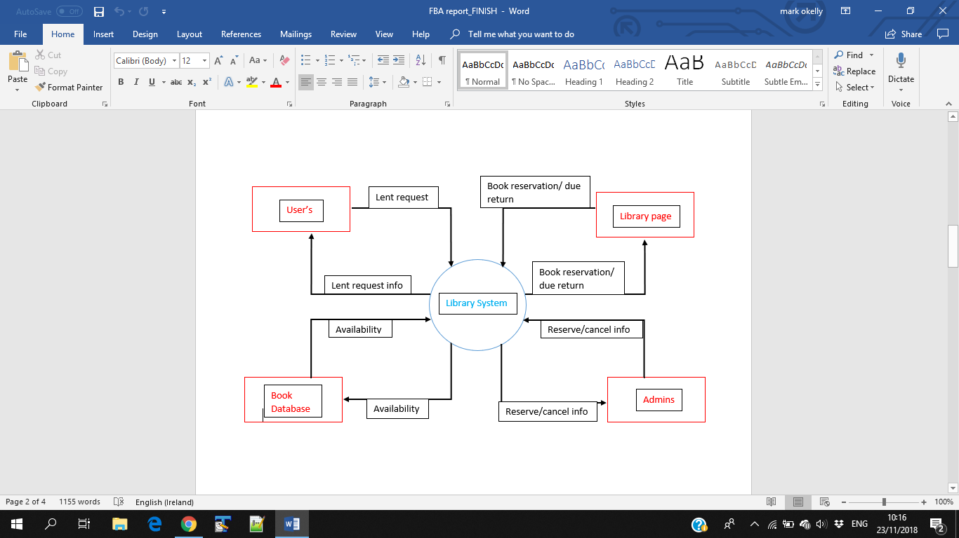

Decision Tree (decision model):

The planning for making the decision tree was simpler to do. All that I had to do was first to decide the type of decision model was best to display how a user interacted with the college website. I would have to do research and rely on the book BABOK much Like the previous plan for the data flow diagram. I would also look at other samples of the decision model I chose and find samples then do rough sketch’s on book. I would also need to interact with the college website and see which decision diagram model would best suit the project.

The reasons why I chose the decision tree table diagram was because it is the easiest to understand for anyone and simply describes how a user for example, who is a student or teacher interacts with the NCI website and Moodle website. It was also the easiest to make as I understood how the model worked but I wanted to see examples as well. The other decision models which were the decision table and decision requirements diagram were the two models I was considering doing at first. However, as I went over examples of these models and reviewed them, they became more and more unsuitable to use and exactly described how we as users interact with the website. These are the main reasons why I went with the decision tree model as this type goes over the actions that are taken which leads to an outcome based on the choices that were made which describes our interaction with the site.

In order to get an accurate tree diagram of the college website, I simply went onto the NCI’s website and interacted with and as I did so, I wrote down every action I took and which section of the website I access and wrote on a page. The feedback for the decision tree diagram came from my PA as I asked him to review it as well. To his review of it, he had no problems with the diagram and he was able to derive the information from it and was clear to read. The processes were easy to follow and the size of the diagram was all right, as it was spaced out to fill any available room on the sheet. Any information on the diagram was easy to convey. It was some very good feedback to hear and I was going over the review for both diagrams to check for any mistakes one more time. While doing the diagram I also had to interact with the website as a student to make sure of the choices for my diagram and place each action into my diagram.

I also had to read over BABOK and several examples of the tree decision table diagram online to see if I was doing it correctly. One problem I came across was how I should end each decision route that was taken and how long the table should go on for. In the end I decided to end each path of the diagram with a yes and no question, if for example when a user who is logged in as a student and is an undergraduate who wants to register and simple press yes and no. I thought there would be too much information for the diagram so I had to make sure that it was precise and short as it could be as there where many minor details. I did this example several times over the days to see what different paths that all my actions took as I interacted with the website and Moodle. The requirements for this technique are also the same with the data flow requirements in which I must interact with the college system and see how I can plan a decision tree out of interacting with the website. Another requirement is that I need someone to review the diagram so that I can correct any mistakes on it. These are the primary requirements for my techniques planning and finishing my techniques for both of the diagrams.

Tree decision model:

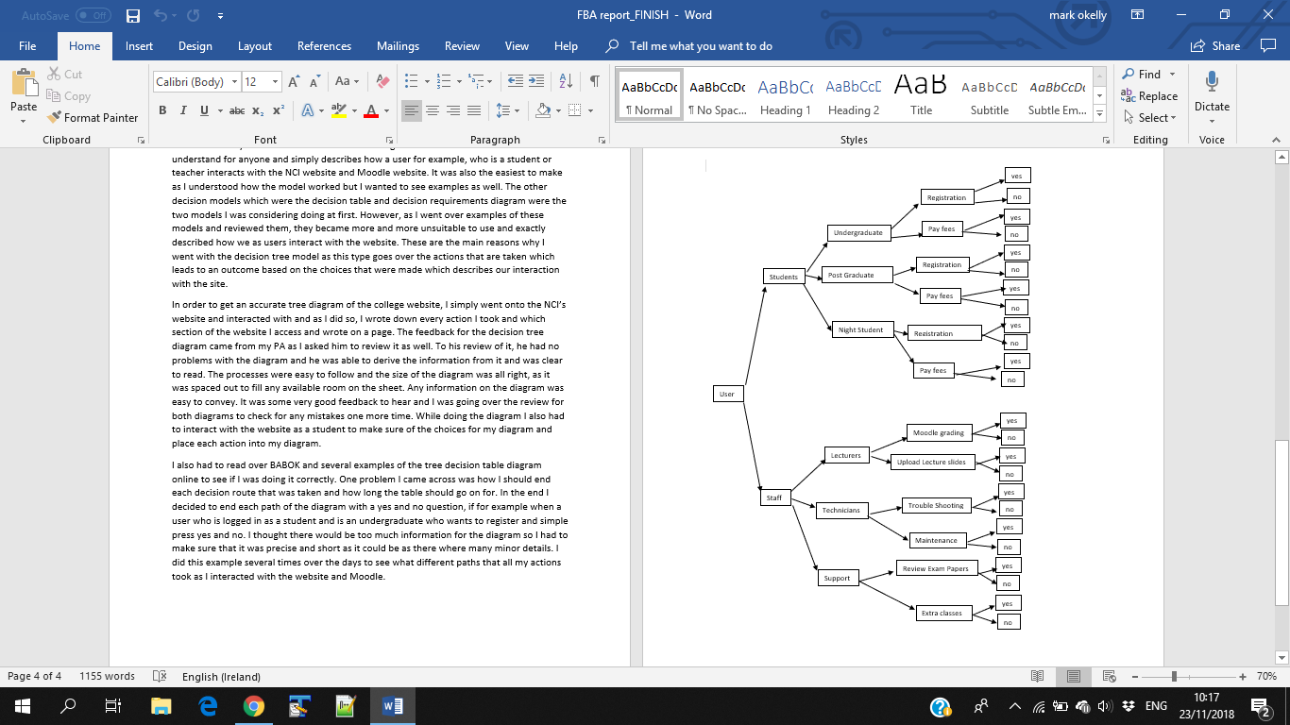

**Planning, Conducting and Documentation Progress week 10 for rout cause analysis and swot**

**Rout cause analysis: review proposed solutions:**

We conducted a meeting to review previous solution. the stakeholders requested to make changes to current solution and provide a detailed solution accompanied with well researched solutions: we focused on the 4 problems causes and we developed a new strategy of how to search for the best solution for each problem. For that reason, we found the extra RCA analysis we done earlier useful, we tried to combine the results and search for appropriate solutions depending in following factors:

* Level of impact on the NCI organization
* priority

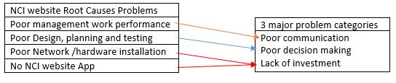

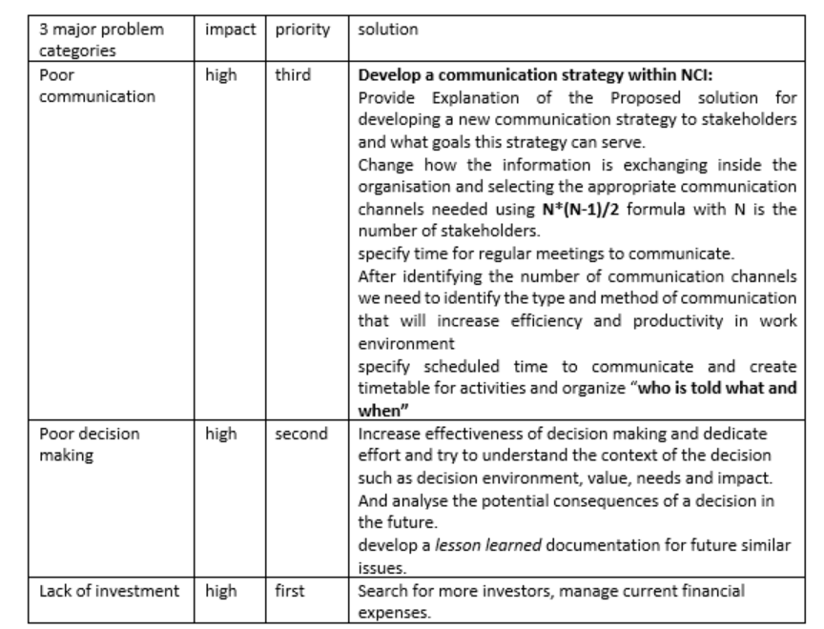

**impact:** estimate the impact of the problem in NCI organisation

high= high impact/ medium = medium impact/ high= high impact

Lack of investment has high impact on the organisation and its responsible for two important areas, Poor Network /hardware installation and Not creating NCI mobile App yet. For this factor it’s the number one priority in the list.

Poor decision making has high impact on the organisation and its responsible for Poor Design, planning and testing and its number two priority in the list

Poor communication has high impact on the organisation and its responsible for Poor management work performance, and its number three priority in the list.

**SWOT:**

The Final result of swot analysis gave the stakeholders clear understanding of the strength of NCI website like good content, high security, social media integration and matured website and outlined the weaknesses that need to be improved and the opportunities that NCI organisation can take advantages of to attract more users like market development and user experience improvement. The last and most important part of SWOT is threats, the NCI organisation faces multiple threats that have a direct impact on the level of the service provided for users. The market demand for a good website and better user experience is high and NCI website do not meet this demand.

The financial pressure is the reasonable factor for not investing on new project to improve quality of NCI website services and as consequences this affects its place within competitors like DIT, DCU and DBS

**Summary:**

NCI needs to prioritise the communication problems existing inside the organisation, Stakeholders know the problems but they need to feel the serious negative effects for poor communication and for that we will reuse the Swot analysis to help them understand the current situation of the organisation.

The process of making decision needs to be changed in near future to avoid negative sequences that directly affect stakeholders specially students.

NCI organisation needs to open for more investors to resolve the current financial pressures. The swot analysis is the perfect start to have better understanding of NCI current situation and overview of the areas that NCI organisation needs to priorities and focus on.

Create strategies using SWOT output:

After understanding NCI college goals and problems and analysing needs and solutions, we focused on finding a way to create strategies, we tried to use SWOT and Rout Cause Analysis output and transform into actionable strategies to improve NCI college website.

We started creating the strategy using NCI website strengths list and think of how this strength can be used to ameliorate the list of opportunities and take the strengths list again and find a way to use it to minimize the risk list and use the opportunities list to minimize weaknesses and avoid threats. The output of this steps helped us create a list of suggested strategies as follow:

1. use social media to promote for NCI and attract more students and take students feedbacks about their experience using NCI website and use it to improve the quality of the website
2. reduce effect of hacking by building an advanced security system and start a social media campaign to avoid low demand for NCI services.
3. overcome weaknesses by turning them to strengths by installing new hardware and better network within NCI to provide better learning environment for students and to avoid the effect of competitors in the market

in in the next step we will try to improve our strategy list and find other strategies using the output of rout cause analysis

**Technique Outputs**

* The navigation system on the current NCI Website needs to be completely redesigned to provide a similar or better user experience compared to best practices currently in use by competitors in the industry.
* The layout and organisation of content must also be changed in order to provide a better user experience to the website users. The content itself is fine, but it must be structured and organised much better.
* The project will require a duration of 12 weeks to complete. This is from the first day of the initiation phase until the point of closure.
* The personnel required to carry out this amount of work within this timeframe will be a four person team consisting of a Senior Web Developer, a Junior Web Developer, an Accounts Manager and a Web designer.
* The total cost required to hire these people for the 12 week duration of the project will be €40,844
* Create an understanding of user interaction to improve NCI’s website.
* Interact with said NCI Website
* Draw diagrams to display the user’s interaction of the site and how the data information flows.
* Take the diagram to make better decisions on improving the websites UI’s.
* Show how the process of data moves with the interaction of website
* Meet stakeholders and show the results of the charts.
* Find programmers to make the improvements to the coding.
* Develop a new effective communication strategy
* Increase effectiveness of decision making
* Find new investors and manage expenses in better way
* Take advantage of social media and use it to promote to NCI website
* Start marketing campaign to increase demand for NCI services
* Replace old hardware by new equipment that suits students’ needs
* Improve the current network installation to support virtualization
* Build an advanced security system
* Simplify navigation (Discriptive and easy to use)
* More user friendly (Attract users)
* Re size image and content when using mobile devices (proper arrangements of both)
* Remove old and unnecessary information(Will gives enough free space for more important contents)
* Modify layout
* Direct and prominent access to Moddle, citrix and office.
* Increase traffic capasity size.

Bibliography

Cadle, J., Paul, D. and Turner, P. (2015). *Business analysis techniques*. Swindon: BCS The Chartered Institute for IT, p.200.

Collinsdictionary.com. (2018). Workshop definition and meaning | Collins English Dictionary. [online] Available at: https://www.collinsdictionary.com/dictionary/english/workshop [Accessed 10 Oct. 2018].

Famuyide, S. (2018). *Root Cause Analysis: The 5 Whys Technique*. [online] Business Analyst Learnings. Available at: <https://businessanalystlearnings.com/ba-techniques/2013/2/5/root-cause-analysis-the-5-whys-technique> [Accessed 12 Oct. 2018].

Free-management-ebooks.com. (2018). [online] Available at: http://www.free-management-ebooks.com/dldebk-pdf/fme-swot-analysis.pdf [Accessed 12 Oct. 2018].

IIBA (2015). *BABOK*. 3rd ed. [Toronto]: International Institute of Business Analysis, pp.226, 271.

Modernanalyst.com. (2018). *An Overview of Root Cause Analysis > Business Analyst Community & Resources | Modern Analyst*. [online] Available at: <https://www.modernanalyst.com/Resources/Articles/tabid/115/ID/2341/An-Overview-of-Root-Cause-Analysis.aspx> [Accessed 12 Oct. 2018].

Moldmakingtechnology.com. (2018). Four Key Uses of Prototyping. [online] Available at: https://www.moldmakingtechnology.com/articles/why-is-prototyping-important [Accessed 9 Oct. 2018]

Project Management Institute, Guide to the Project Management Body of Knowledge (2013) (PMBOK® Guide) —Fifth Edition, ISBN: 978-1-935589-67-9

Schwalbe, K. (2016). *Information Technology Project Management*. 8th ed. Boston: Cengage Learning, p.197. p.247.

SWOT Analysis Strategy Skills, Team FME, www.free-management-ebooks.com, ISBN: 978—62620-951-0

The-aba.com. (2018). [online] Available at: http://www.the-aba.com/administrator/components/com_event/uploads/59014e456ca677.92343092BABOK_Guide_v3_Member.pdf [Accessed 10 Oct. 2018].

[online] Available at:[http://www.theaba.com/administrator/components/com_event/uploads/59014e456ca677.92343092BABOK_Guide_v3_Member.pdf](http://www.the-aba.com/administrator/components/com_event/uploads/59014e456ca677.92343092BABOK_Guide_v3_Member.pdf)[Accessed 8 Oct. 2018].

www.glassdoor.ie/

Vasylyna (2018). 4StepsforSuccessfulUIPrototyping. [online] Independent Testing – QATestLab. Available at: http://blog.qatestlab.com/2011/02/28/4-steps-for-successful-ui-prototyping/ [Accessed 10 Oct. 2018].